In this Project we will try to demonstrate Autoscaling (scaling up and down) using alarms, and Load balancing between the available instances automatically as the CPU utilization increases for the instances in the private subnet within the VPC.

We will create a bastion server in the public subnet which can connect to the private instances and spike the CPU utilization using a python script for demonstration purposes.

Steps: Create a VPC:

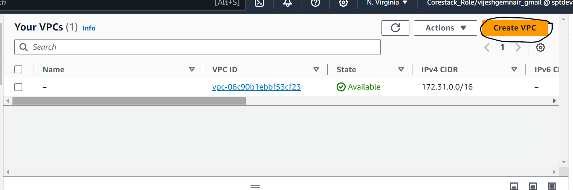

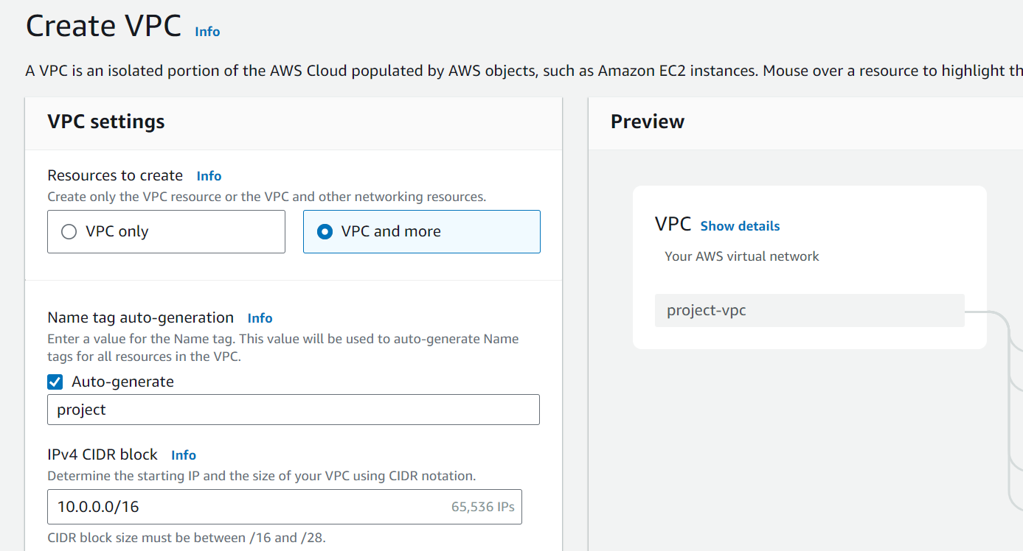

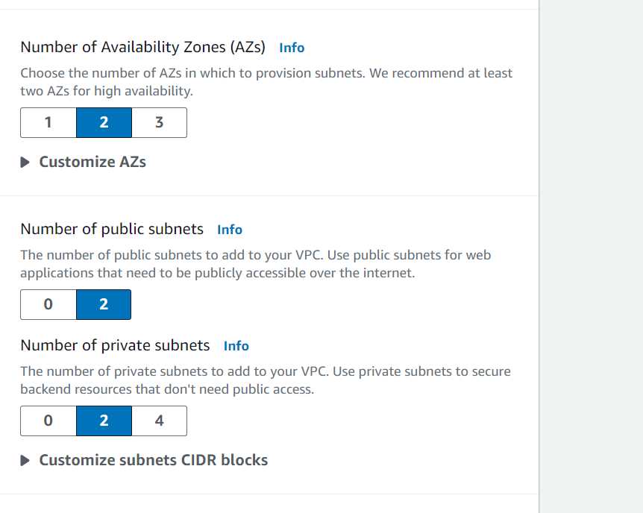

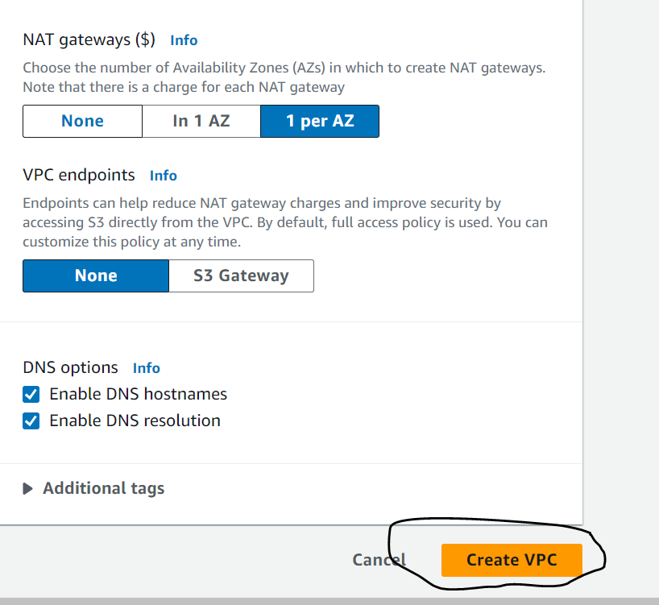

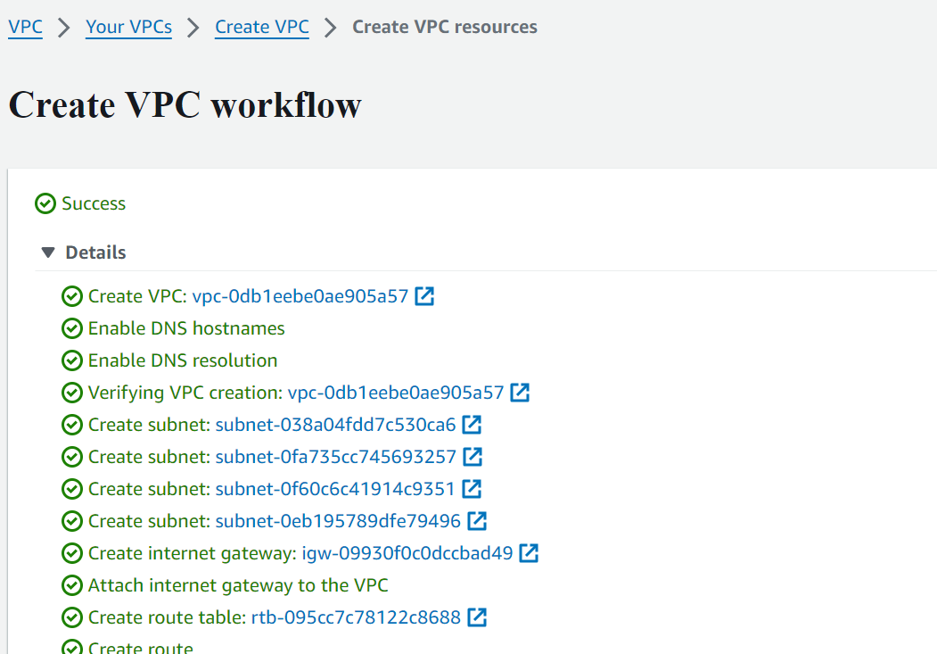

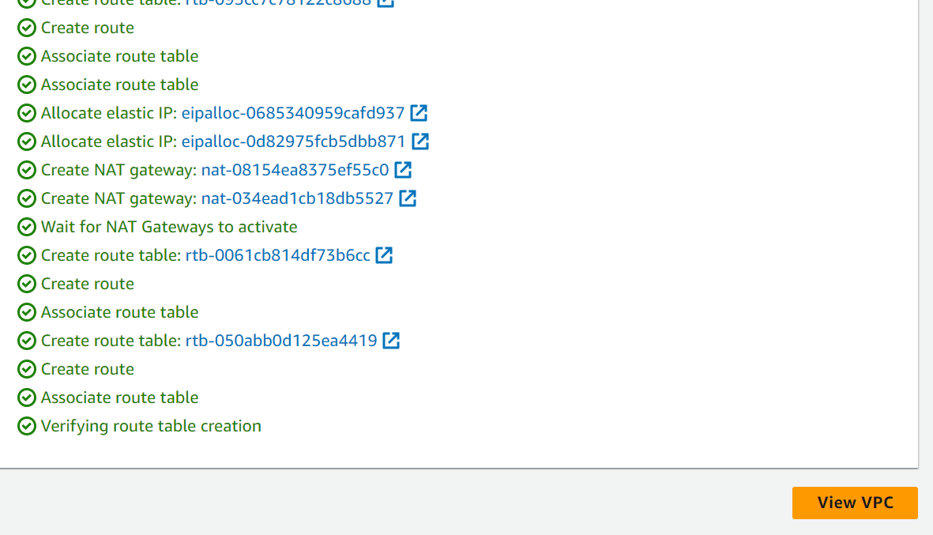

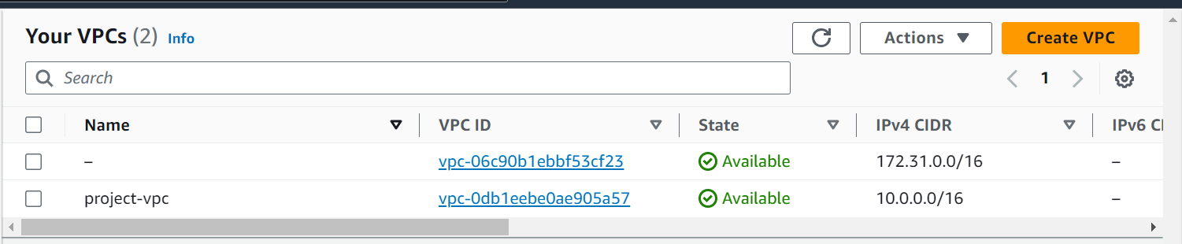

In the above setup, one vpc, two publis subnets, 2 private subnets , 1 internet gateway, 1 nat gateway, 1 public route table and 2 private route tables for each private instances.

Region: US-EAST-1, AZ’s: US-EAST-1A and US-EAST-1B

Step 2: Create Autoscaling groups/Launch templates which will create instances within the private subnets.

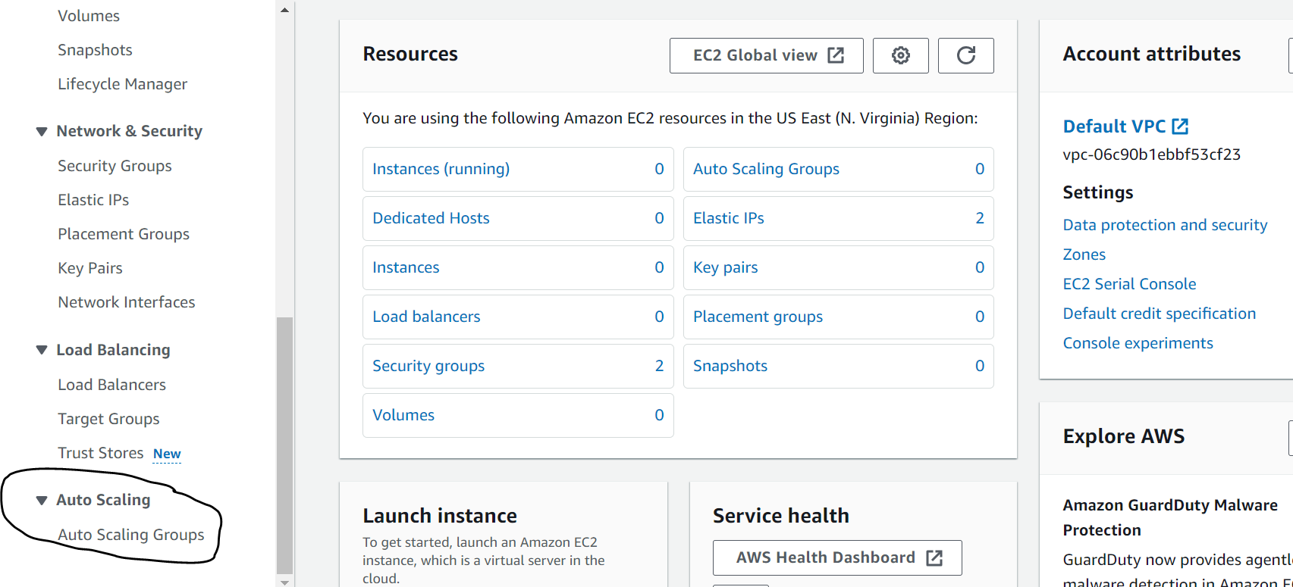

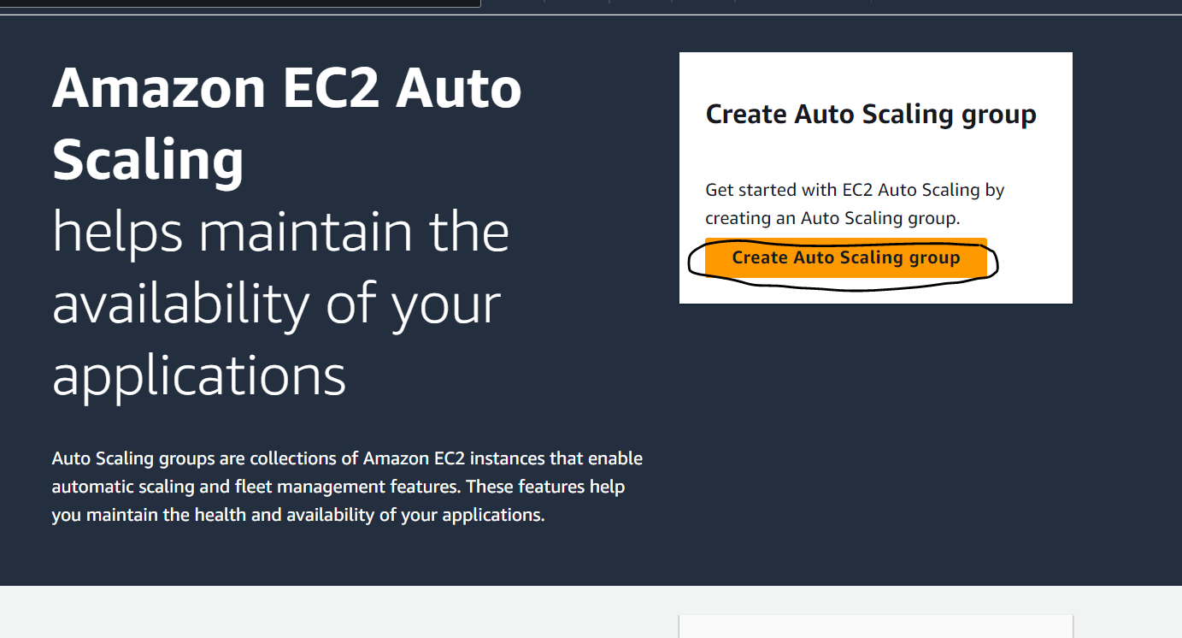

Then Launch the Template first,

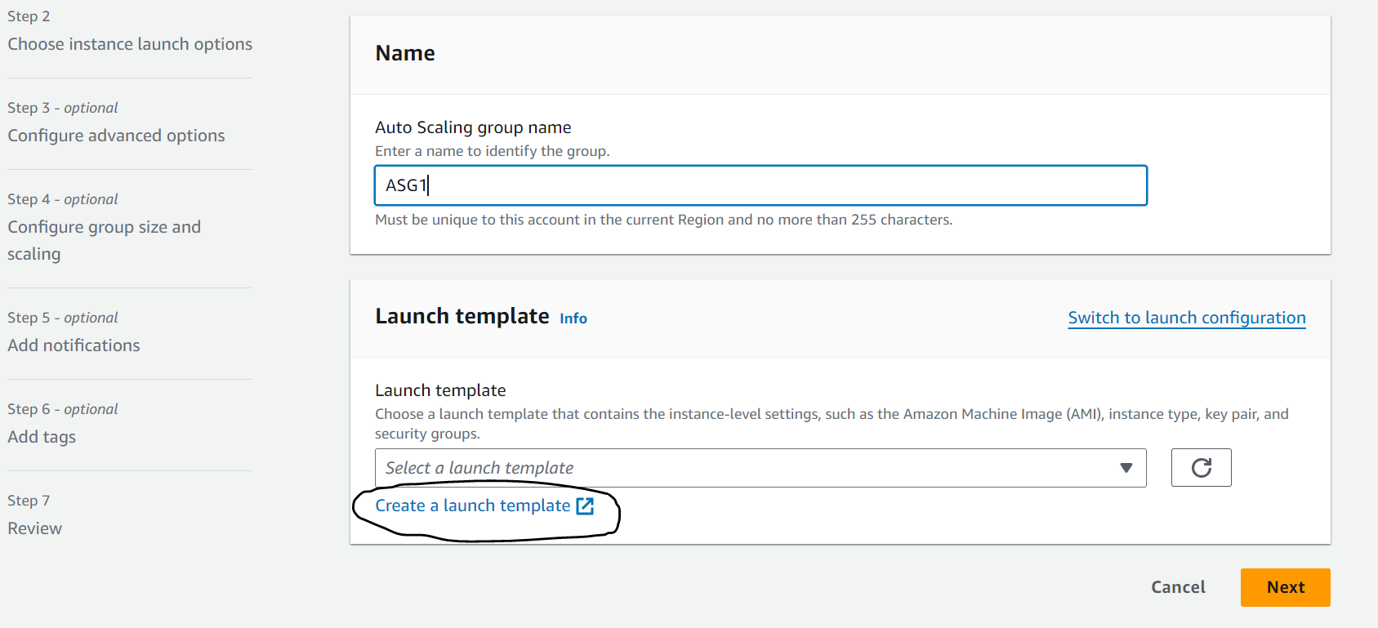

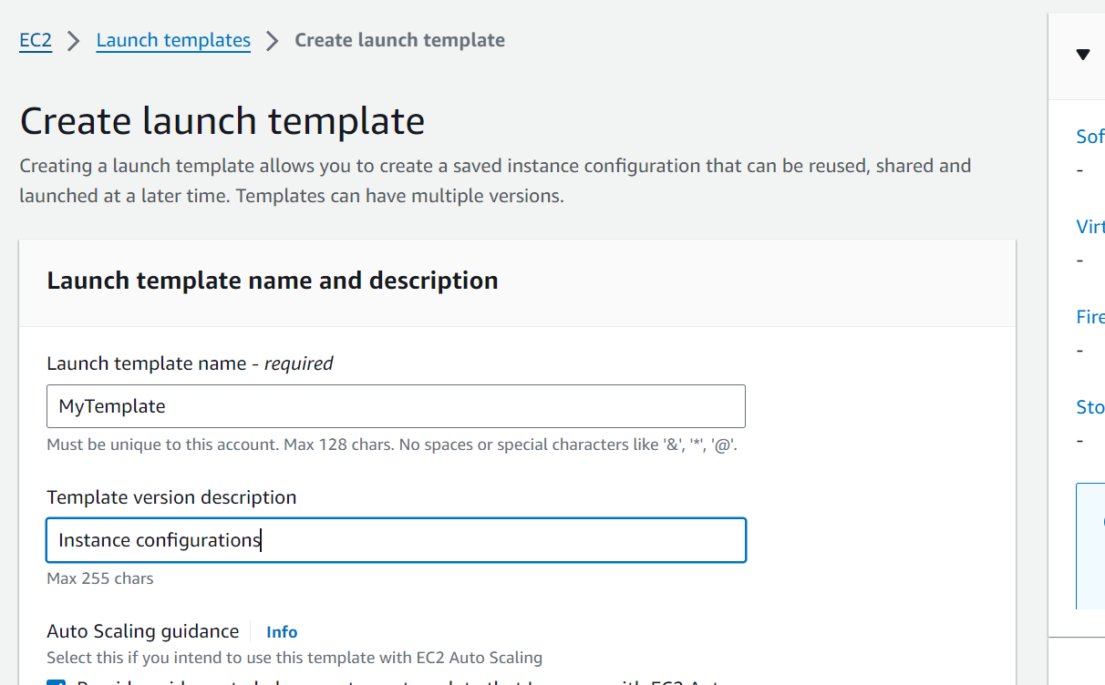

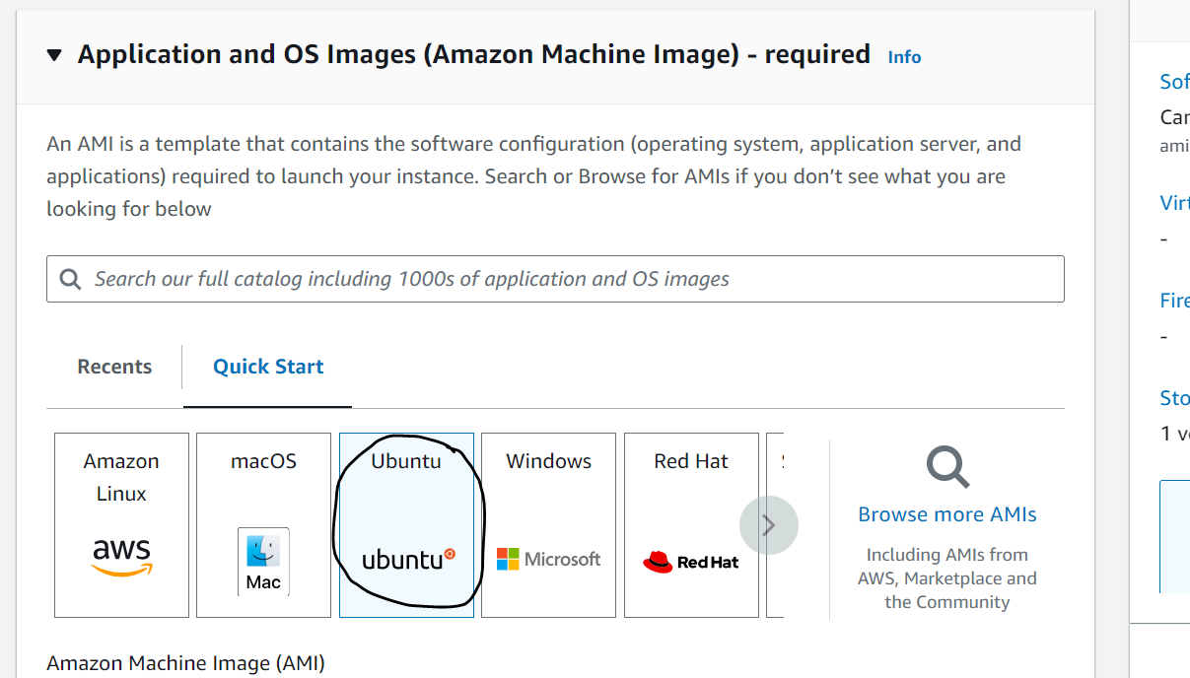

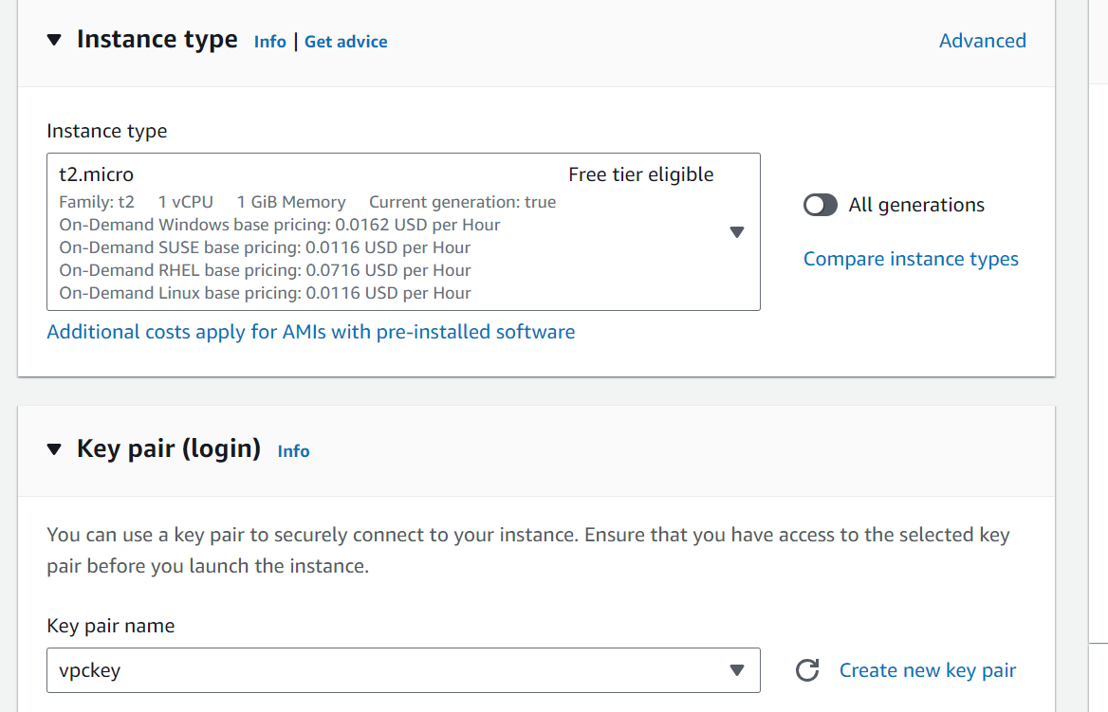

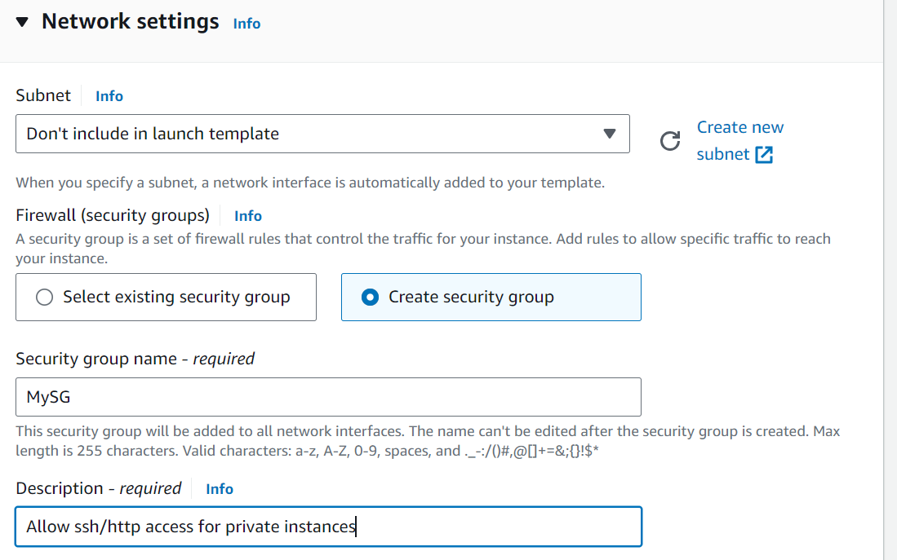

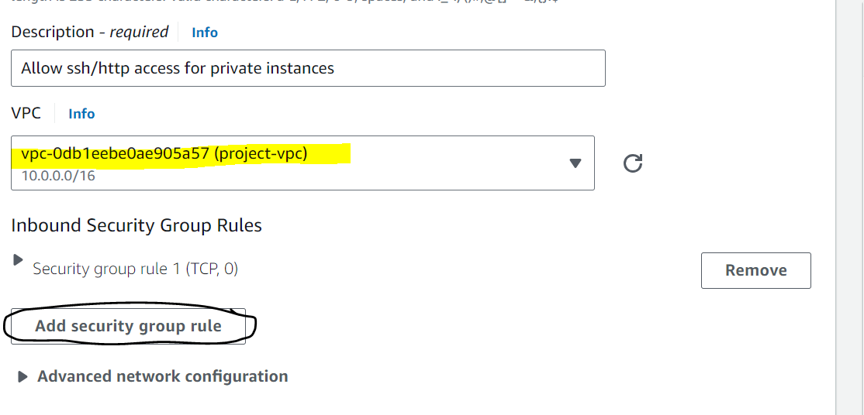

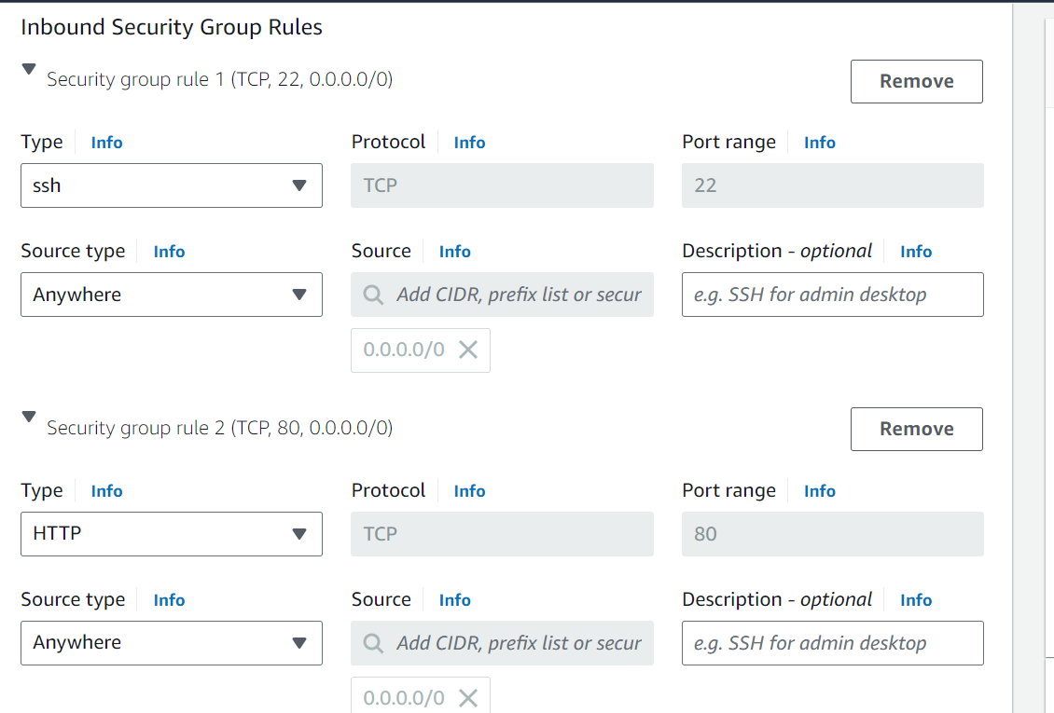

Next go to Advanced details, to configure an apache server and get the respective hostname into the index.html file. We are doing this to demonstrate load balancing so that whenever we browse the domain names we get the hostnames of the respective instances so we can confirm the load is equally distributed across the instances.

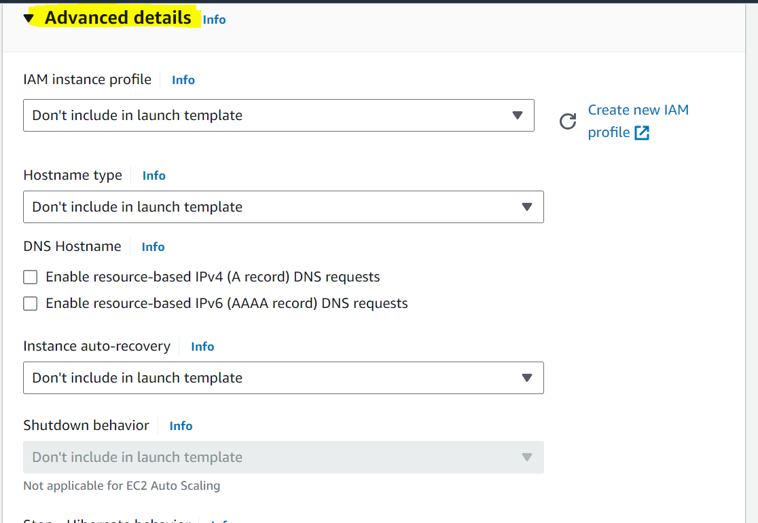

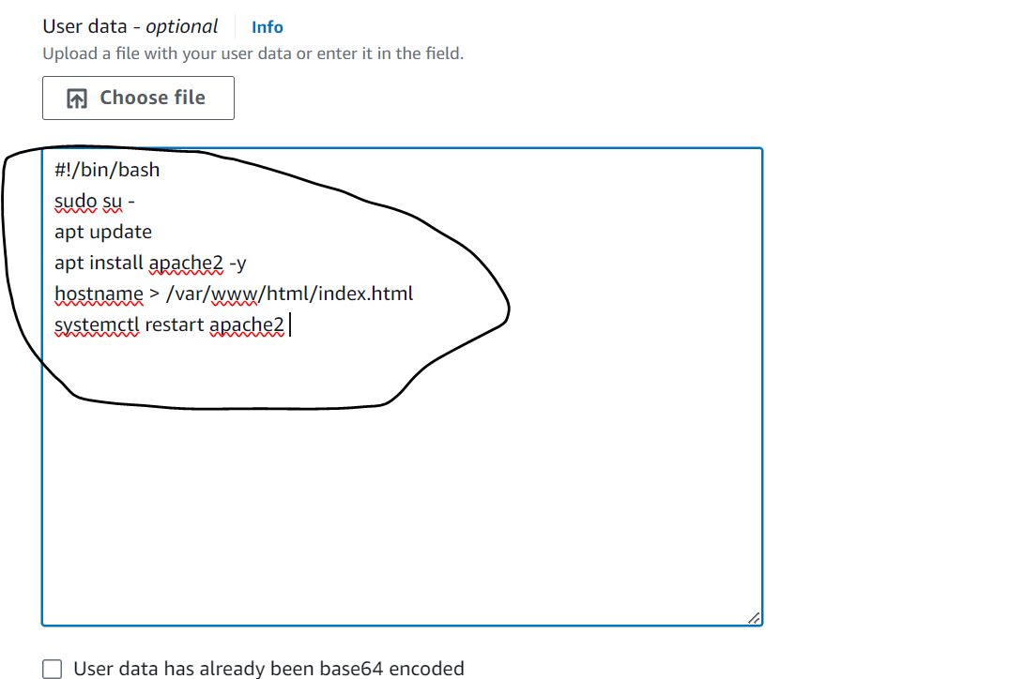

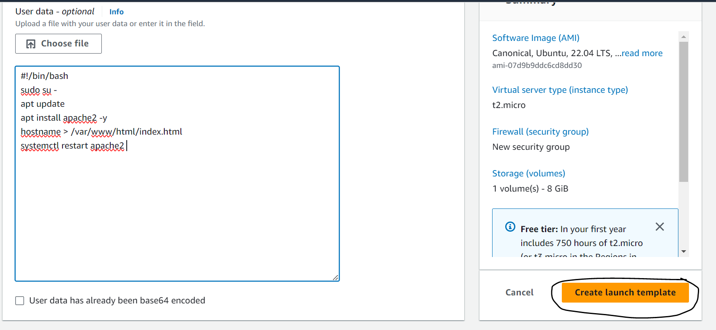

Now proceed with the Autoscaling Group creation:

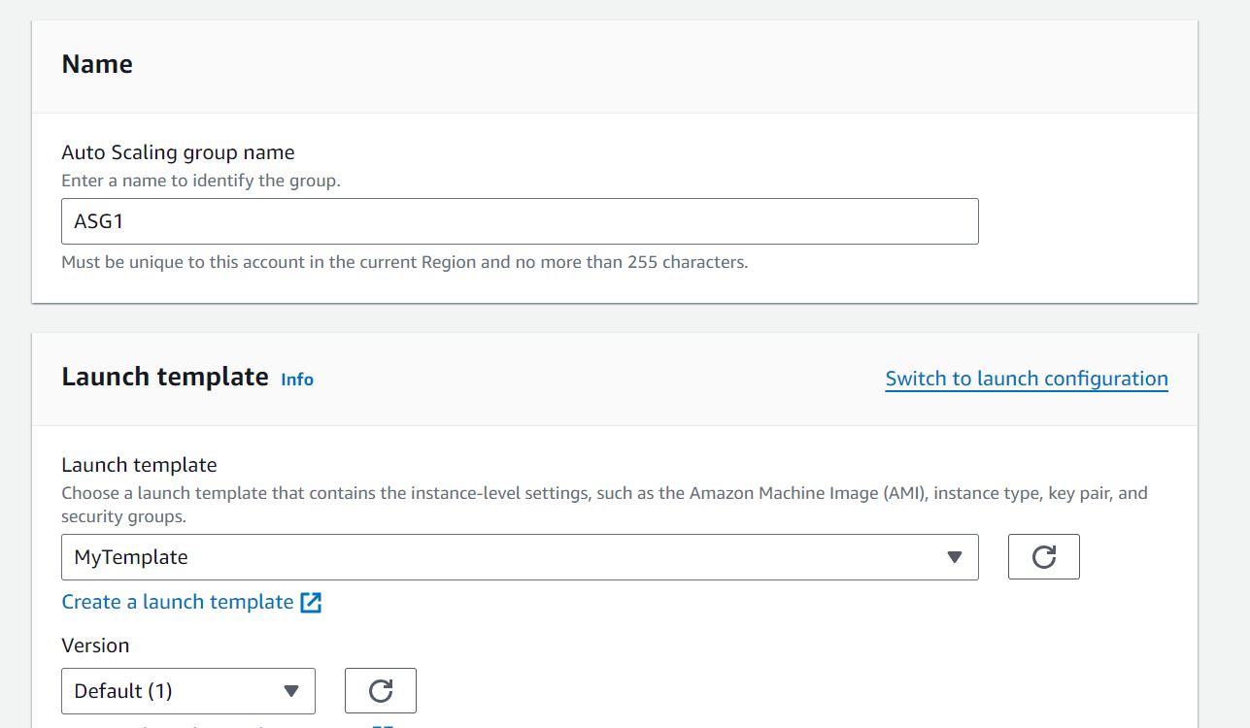

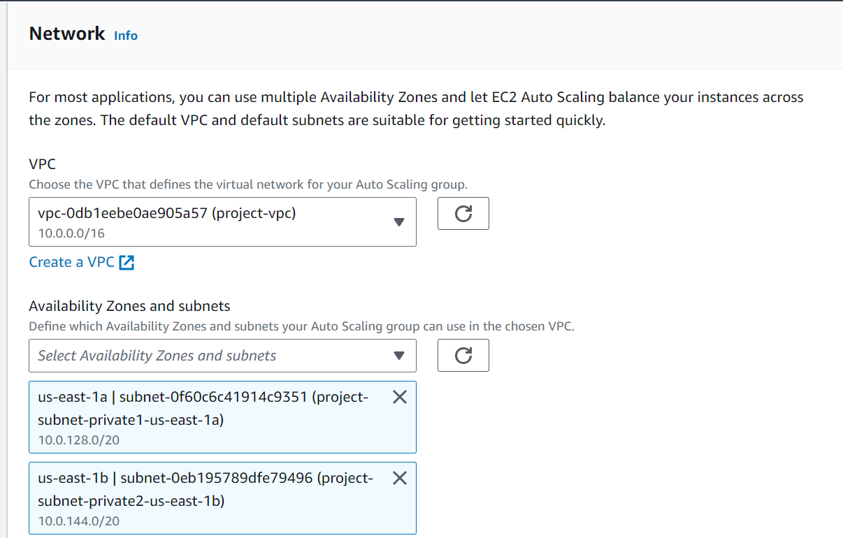

Make sure to select private AZ above as we are creating and scaling instances in private subnets to make the applications secure within VPC.

No load balancing as of now, we will edit this load balancer later once we create one separately.

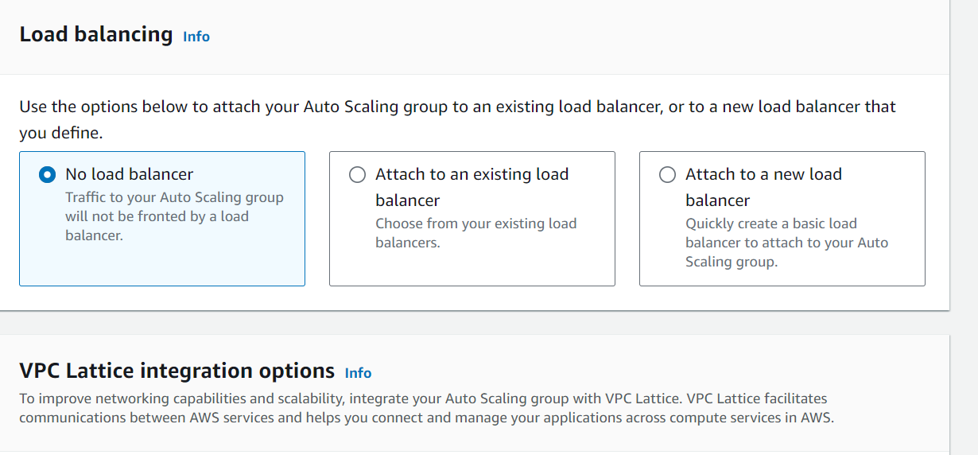

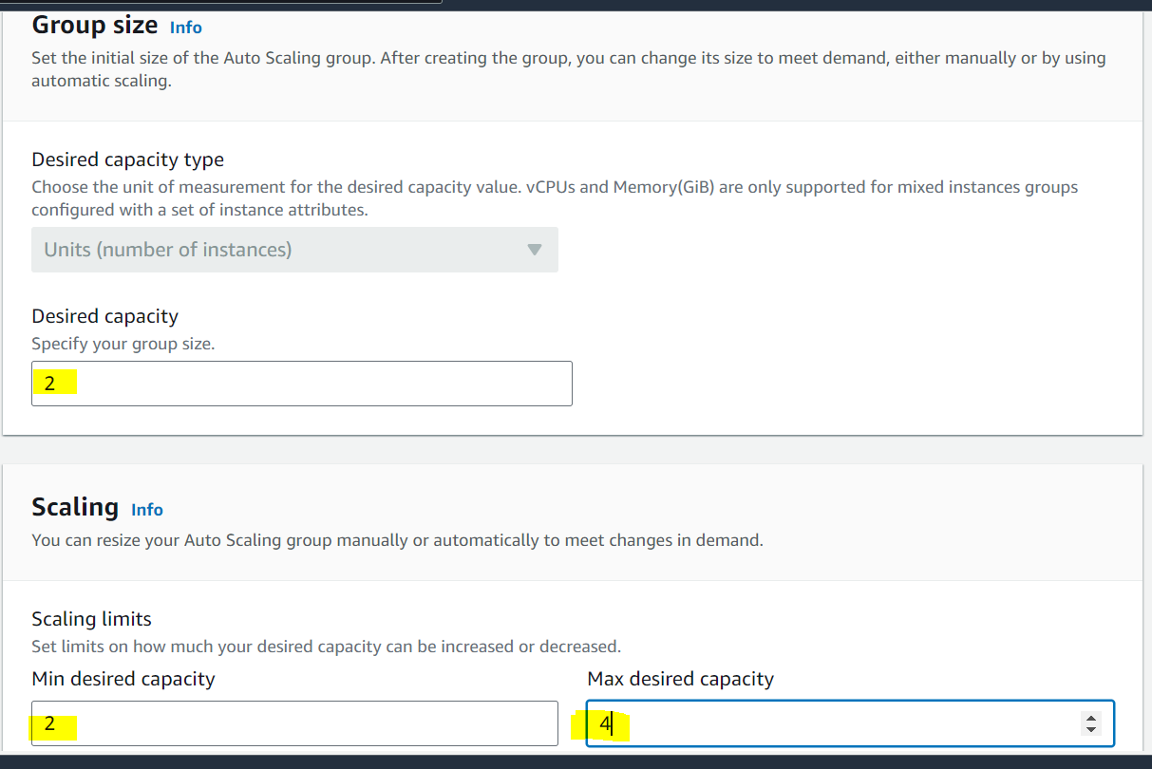

Scaling policy we will edit later:

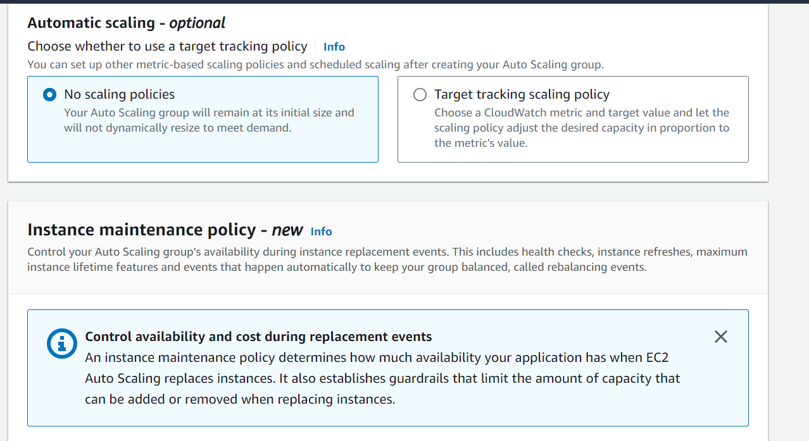

We will create a notification to notify though mail all autoscaling activities as mentioned in the below options:

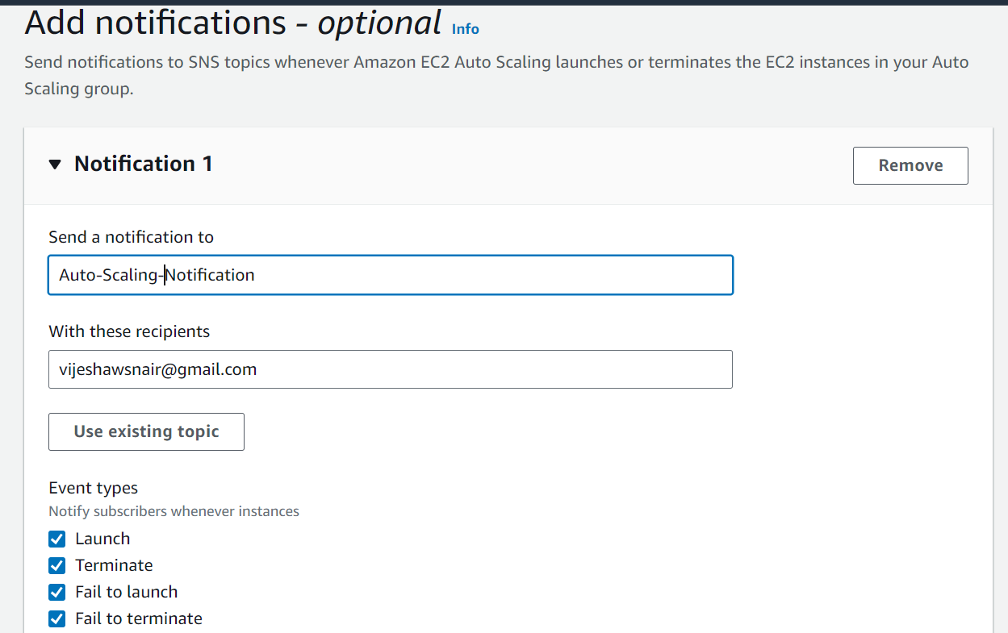

Finally review and launch:

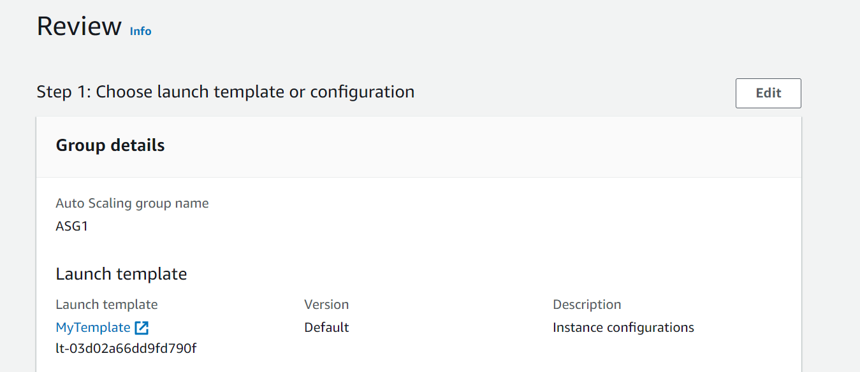

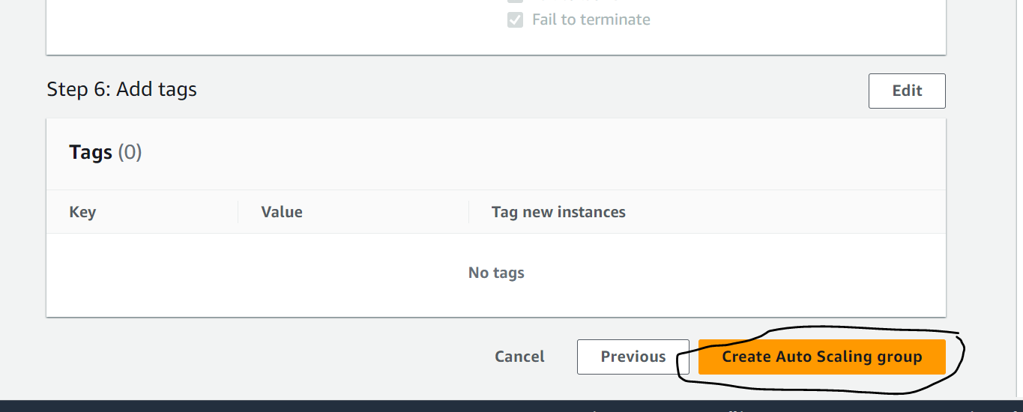

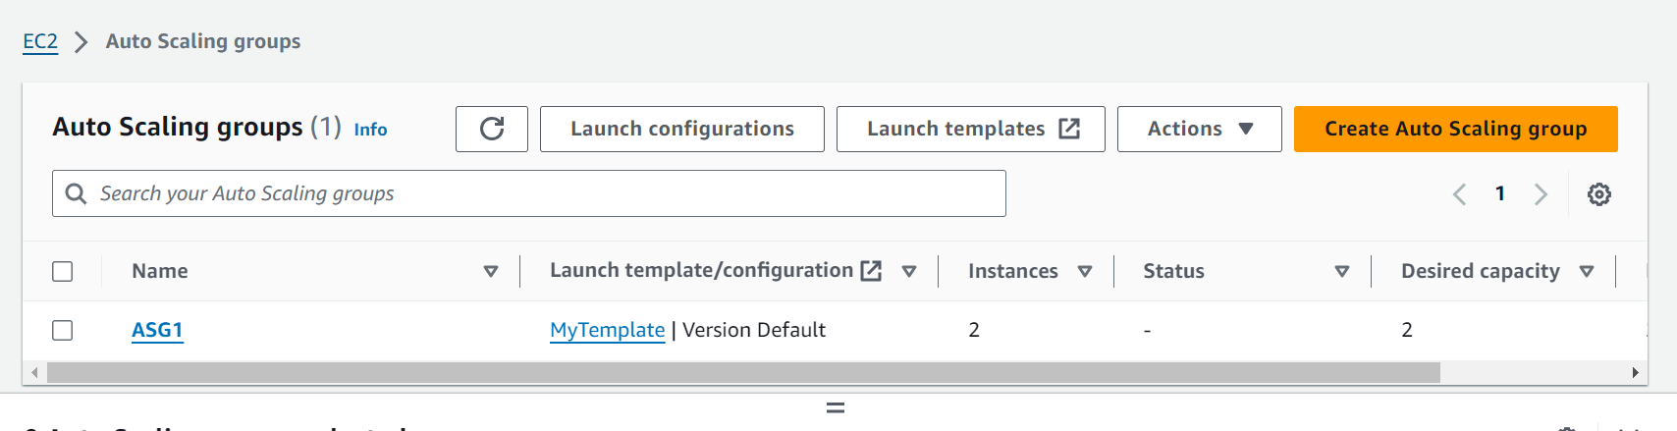

After the above steps, make sure to go to the notification mail and acknowledge the AWS notifications:

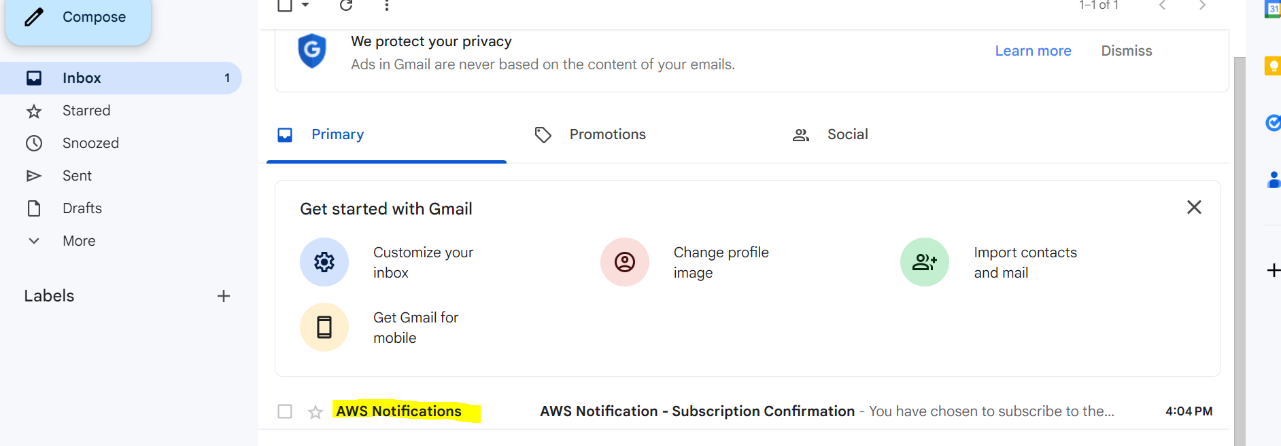

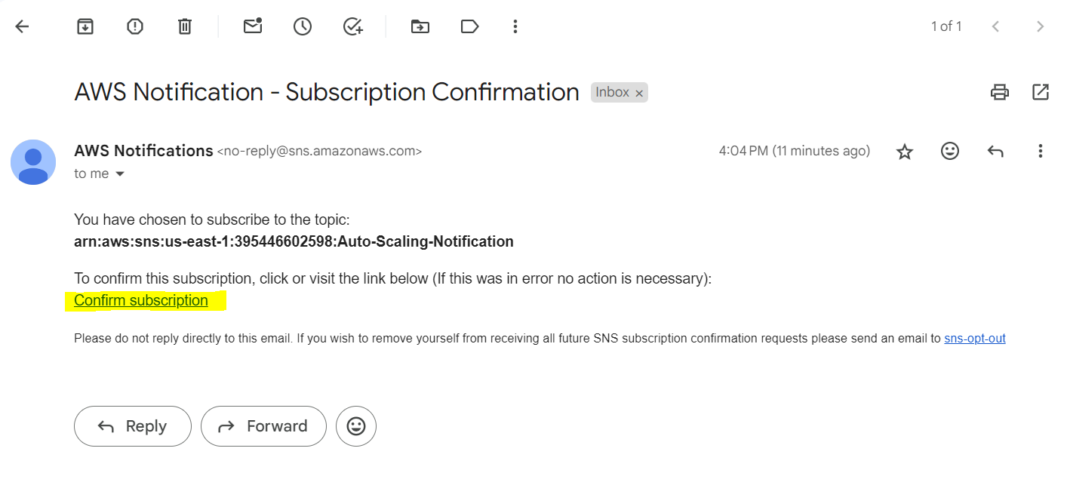

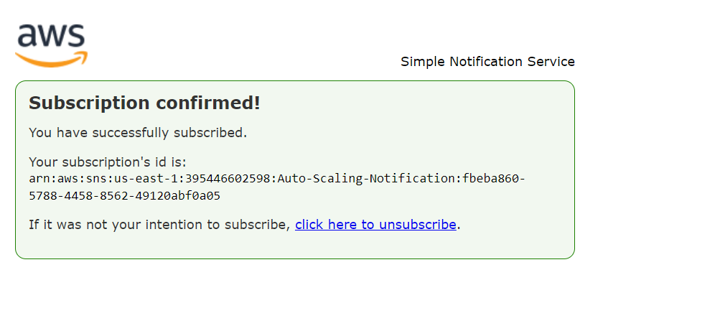

You can verify you SNS in the SNS service:

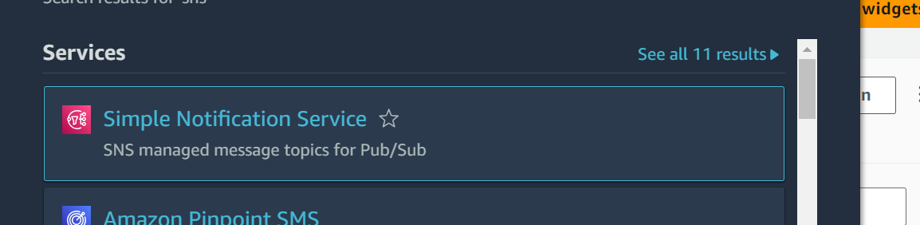

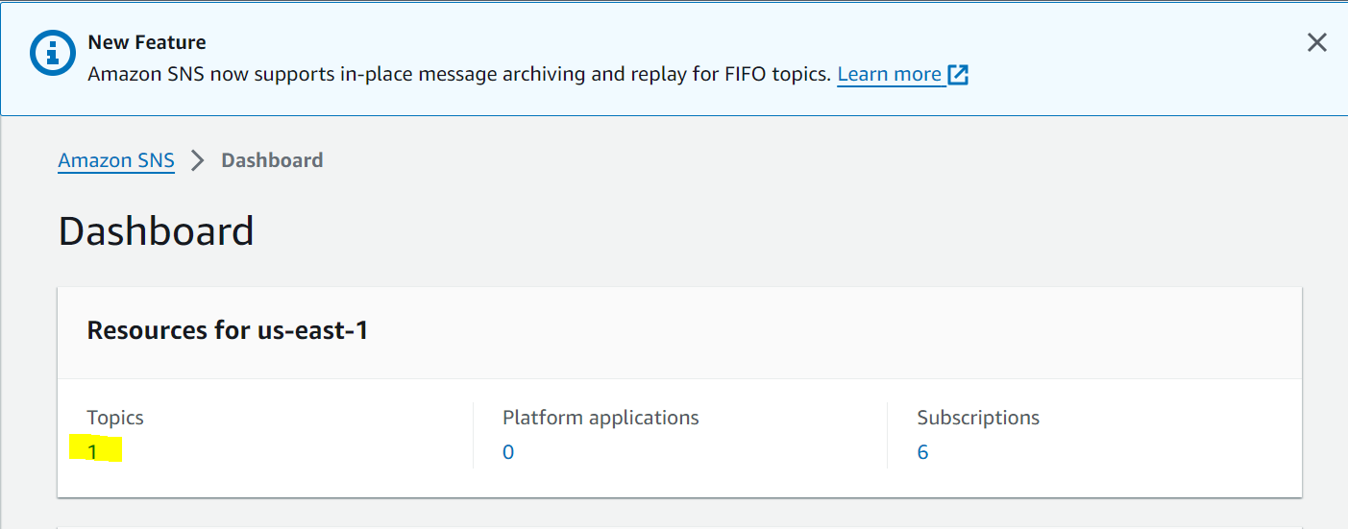

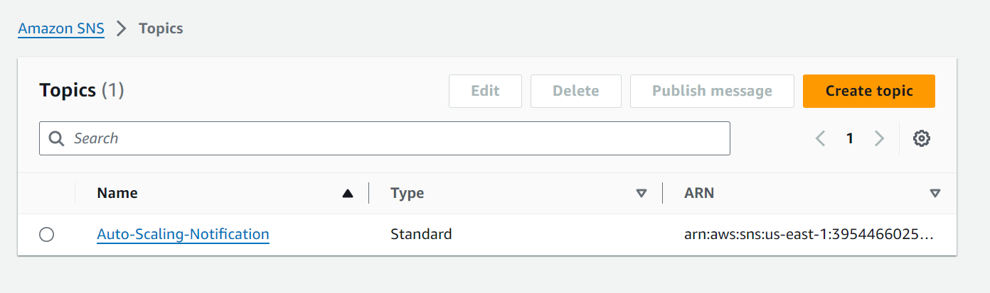

After this the instances will be created and ready like below:

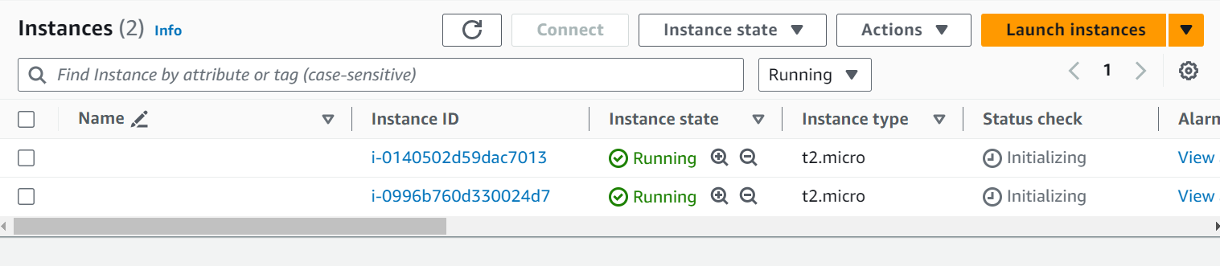

Next we will create one more server in the public subnet for connecting to the private instances:

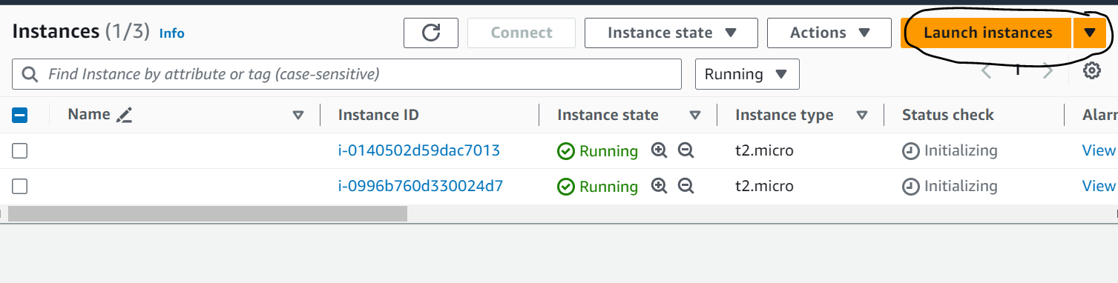

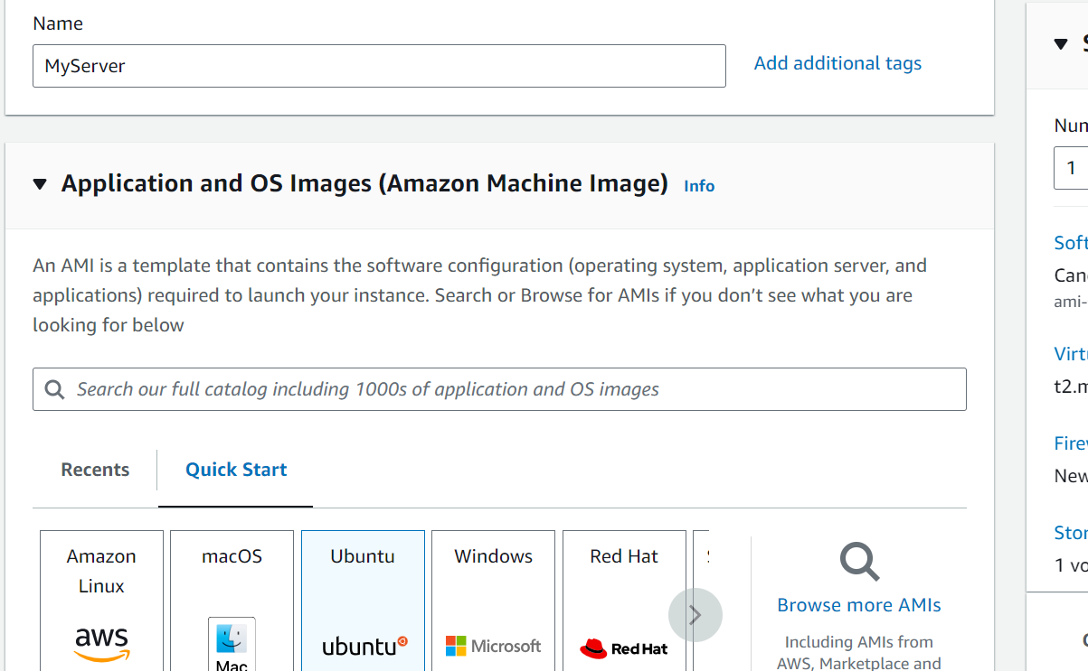

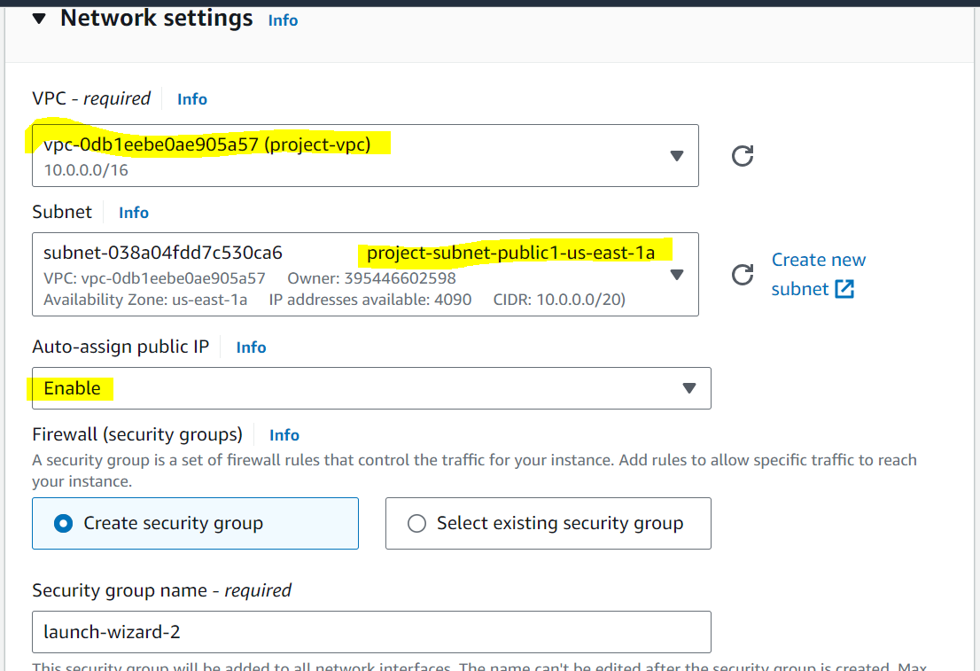

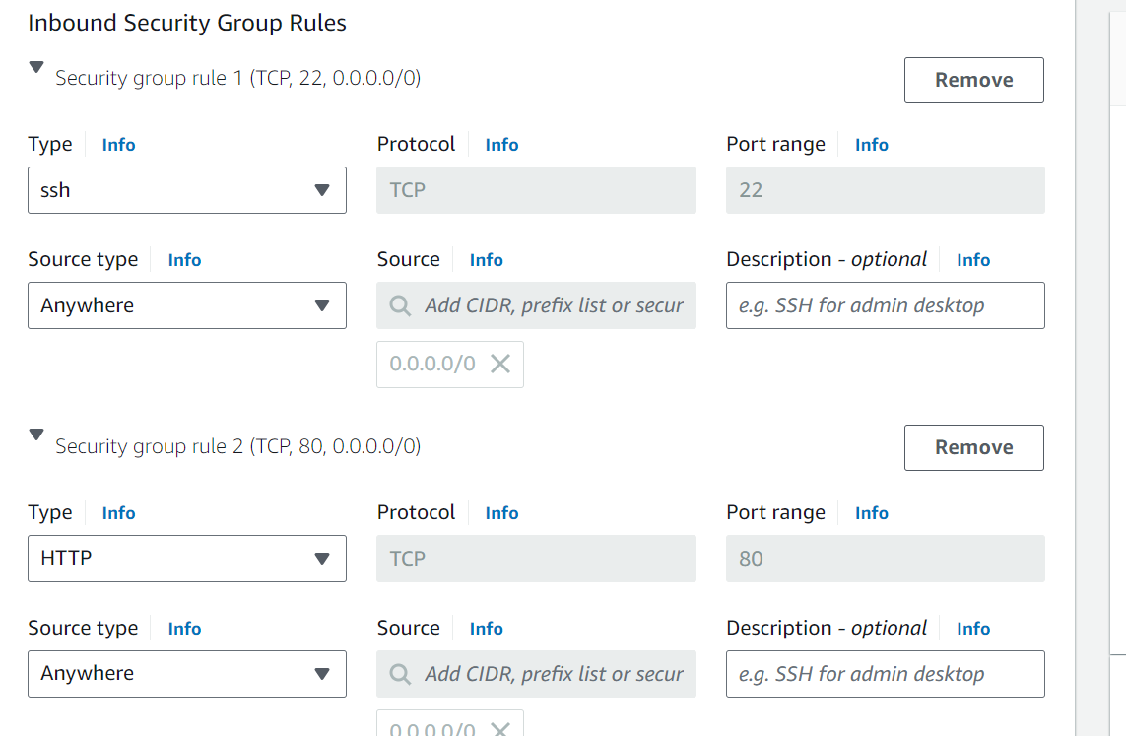

You can also use the earlier created Security group. I am creating a new one. Then launch the instance. For identification purpose I have named the private instances as Instance 1 and Instance 2

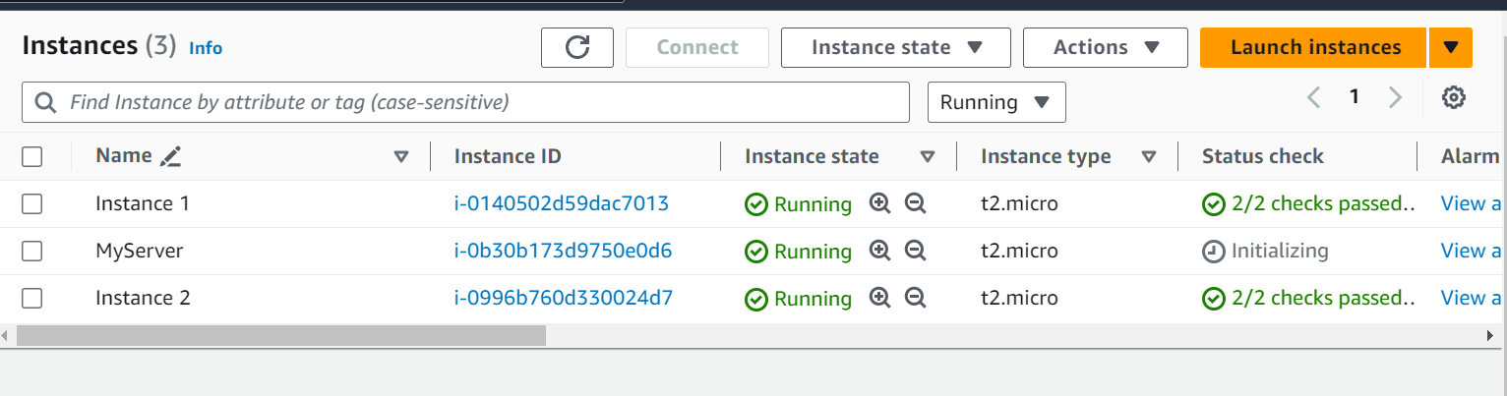

Step 4: Create Application Load balancer and Target Groups:

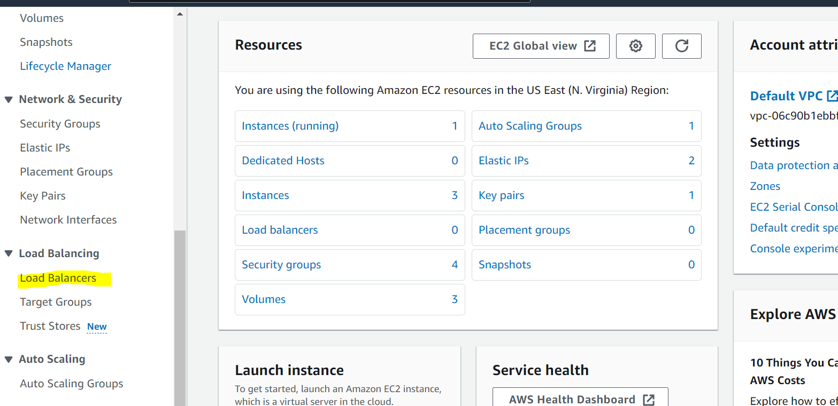

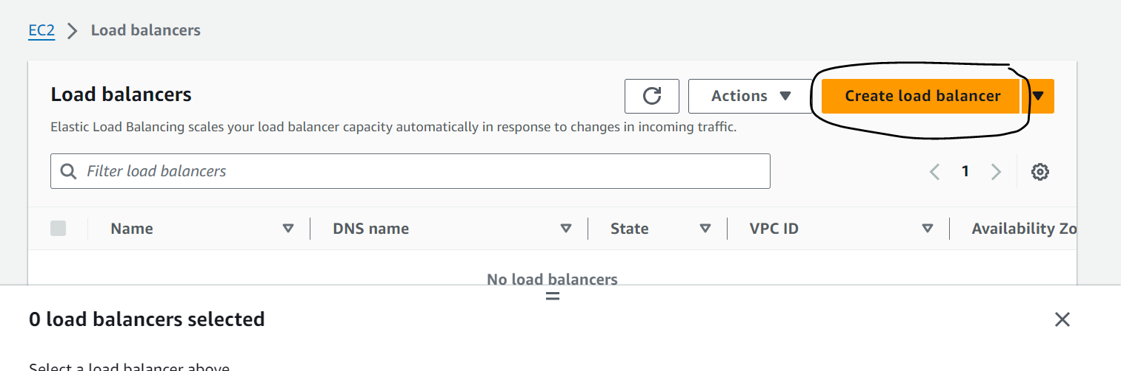

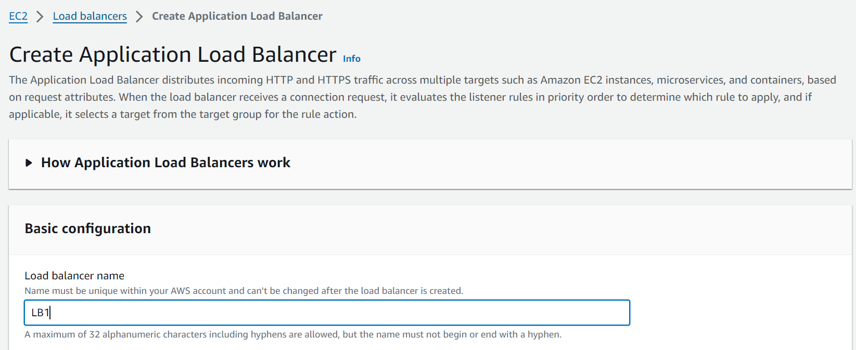

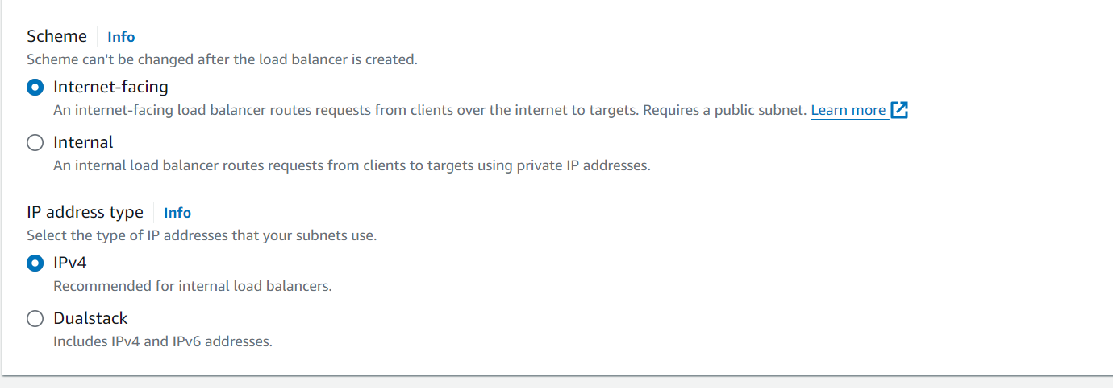

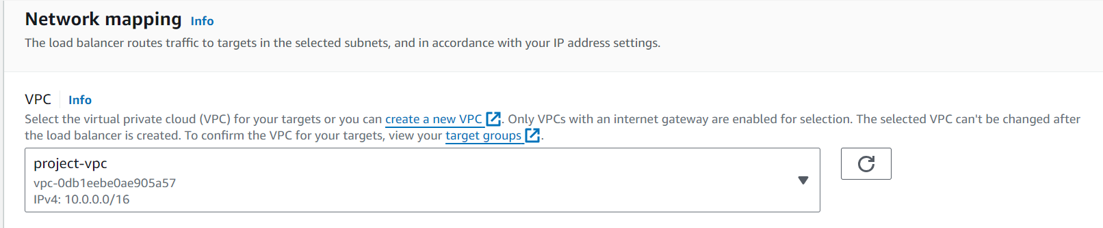

Load balancer should always be in the public subnet. Make sure to select public subnets.

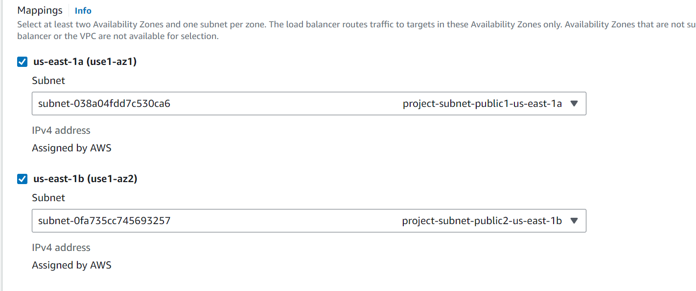

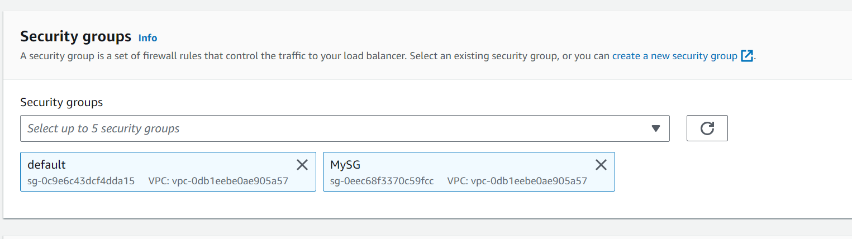

Then create target group:

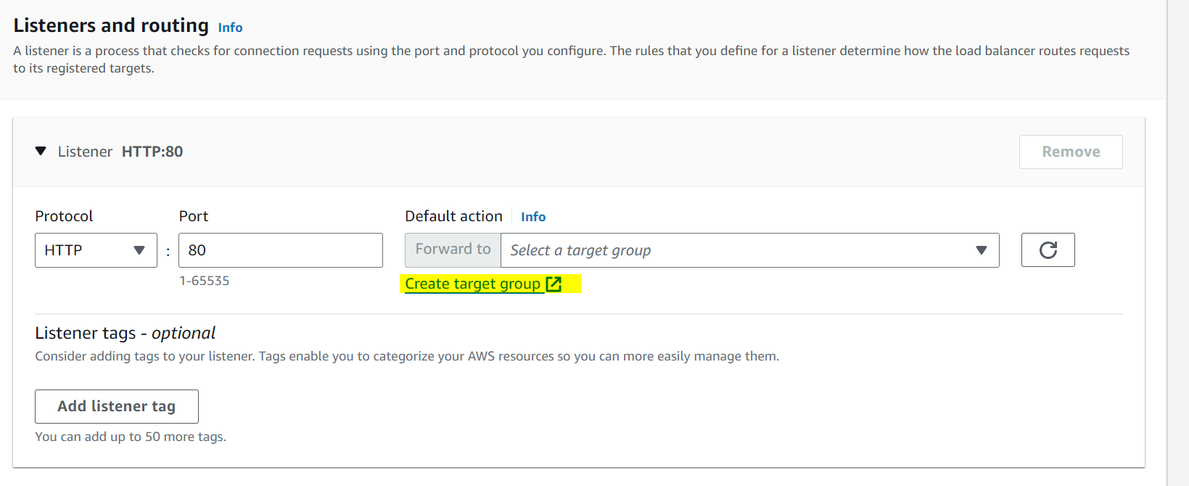

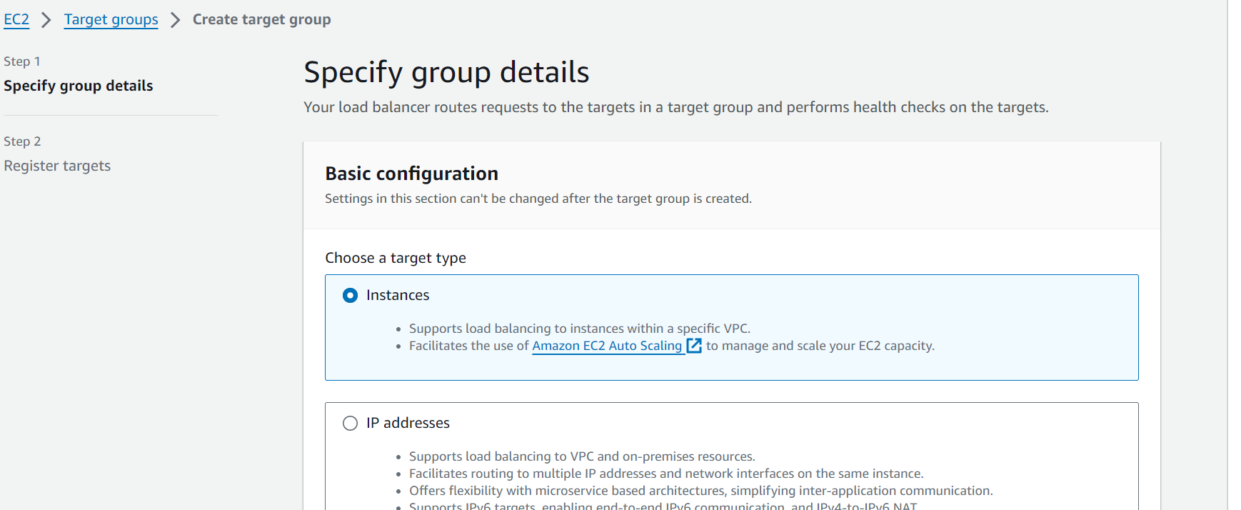

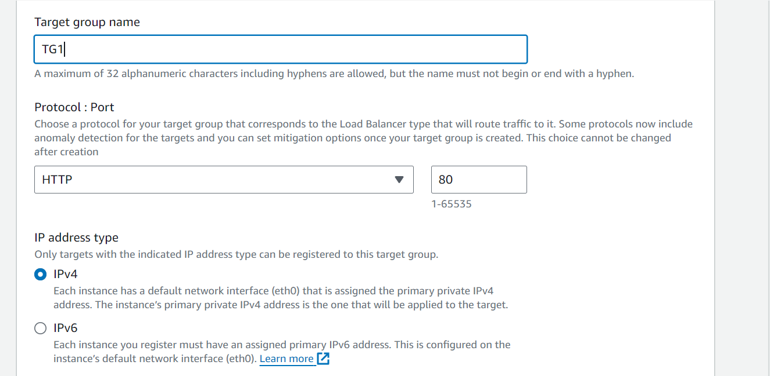

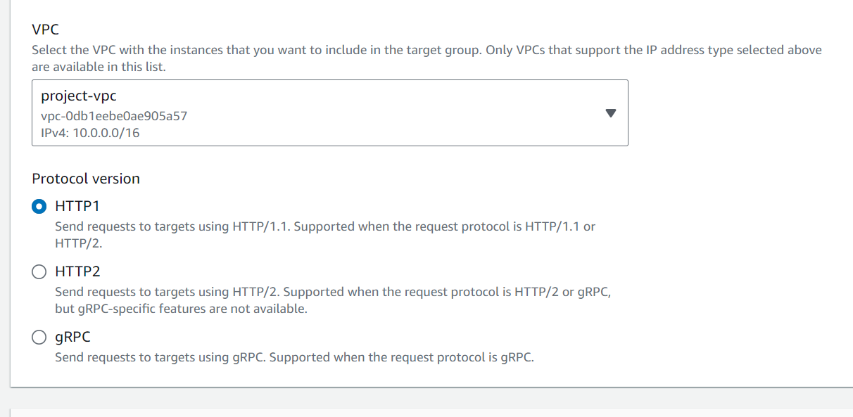

Add the 2 private instances to the target groups:

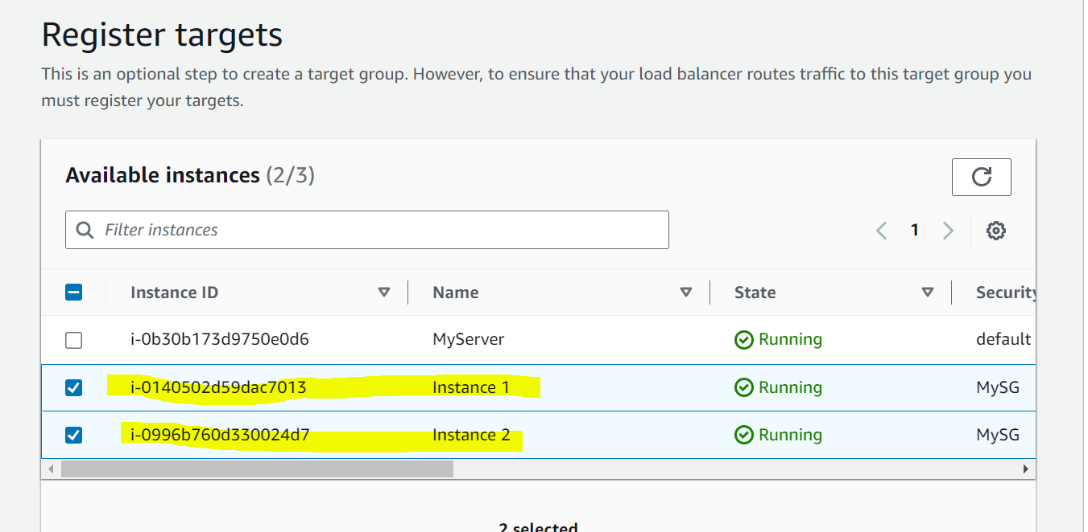



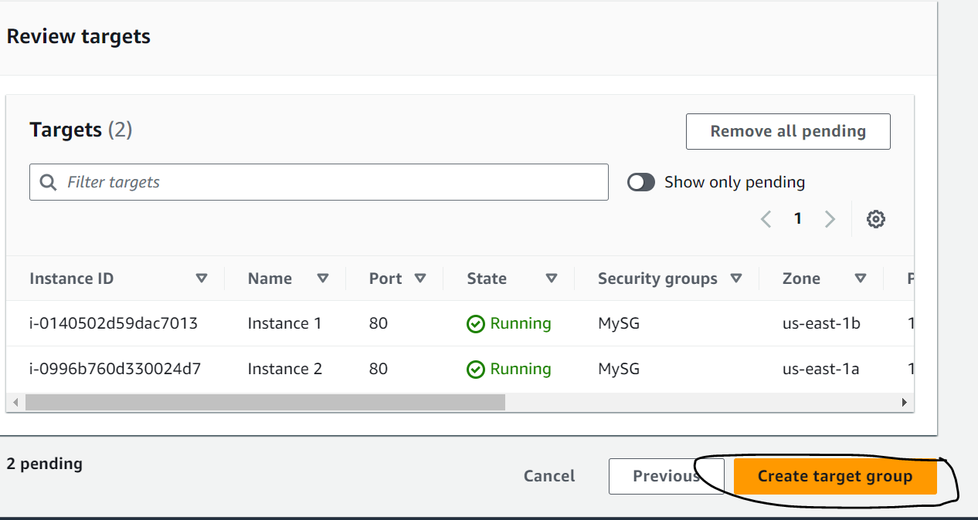

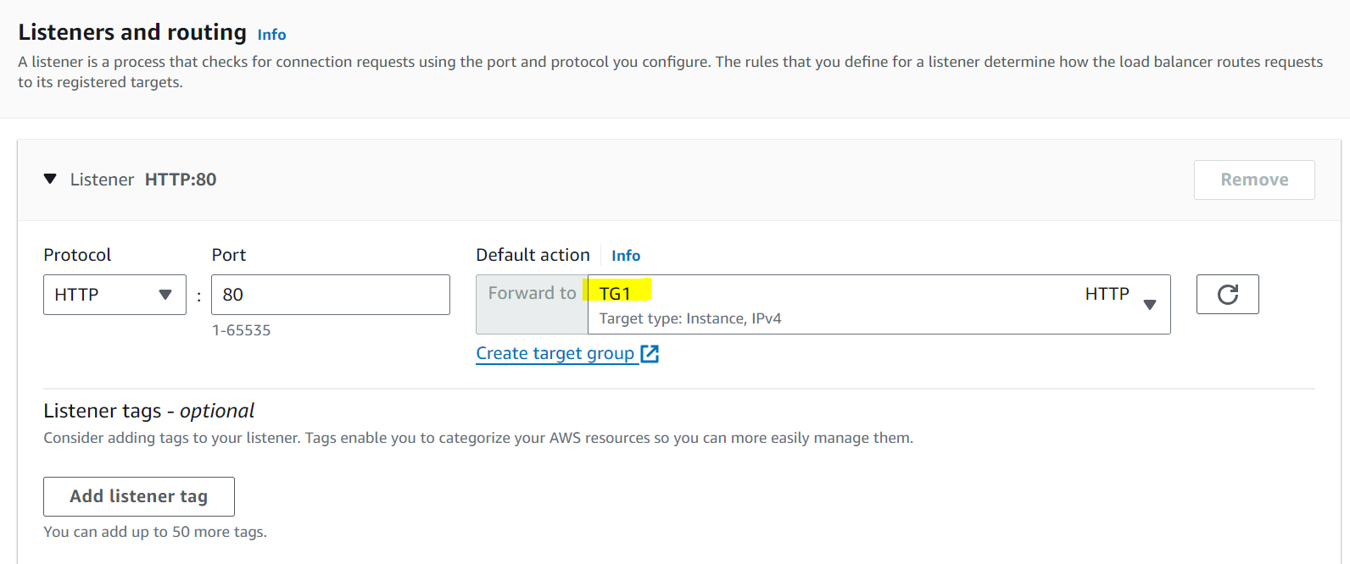

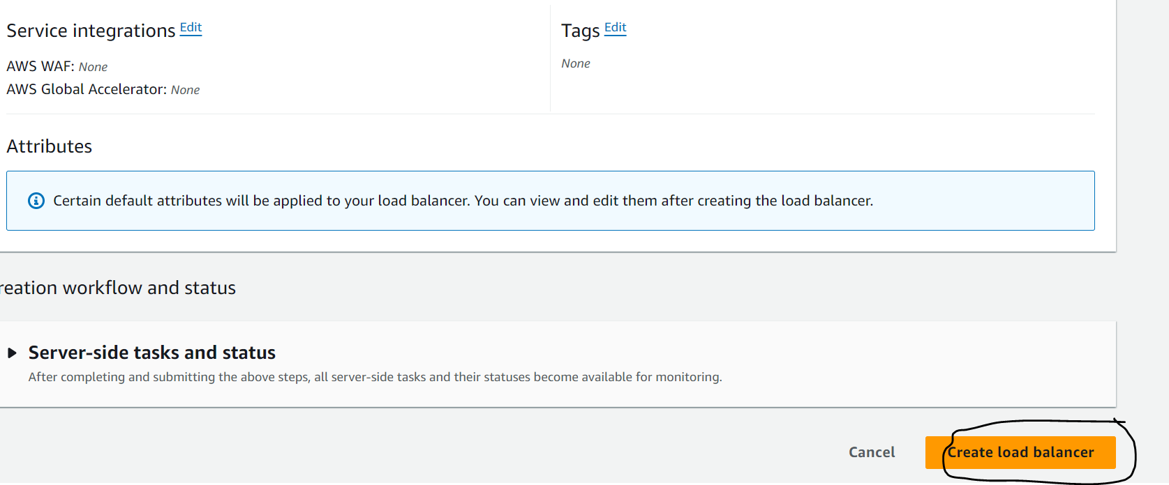

This will create load balancer and target group. Will take few minutes to provision the load balancer and the target groups to be healthy. If the target groups are showing unhealthy it means there is some configuration issue.

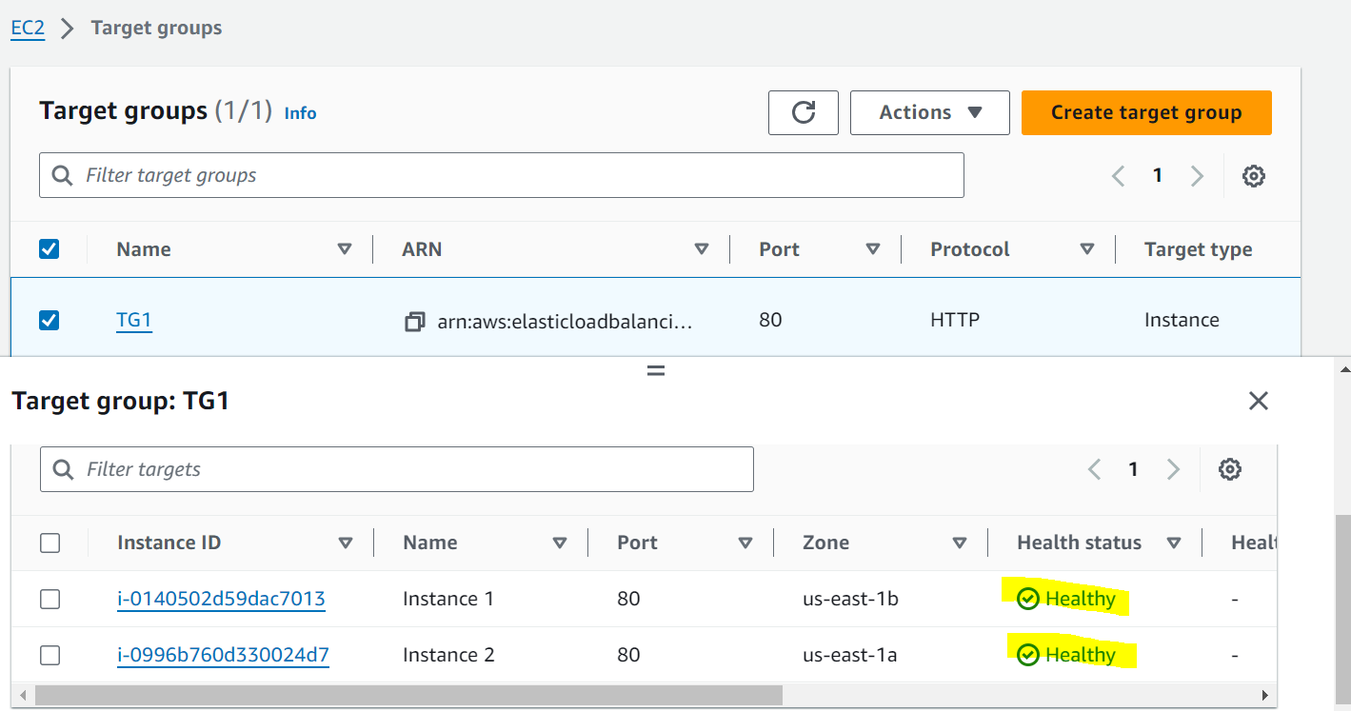

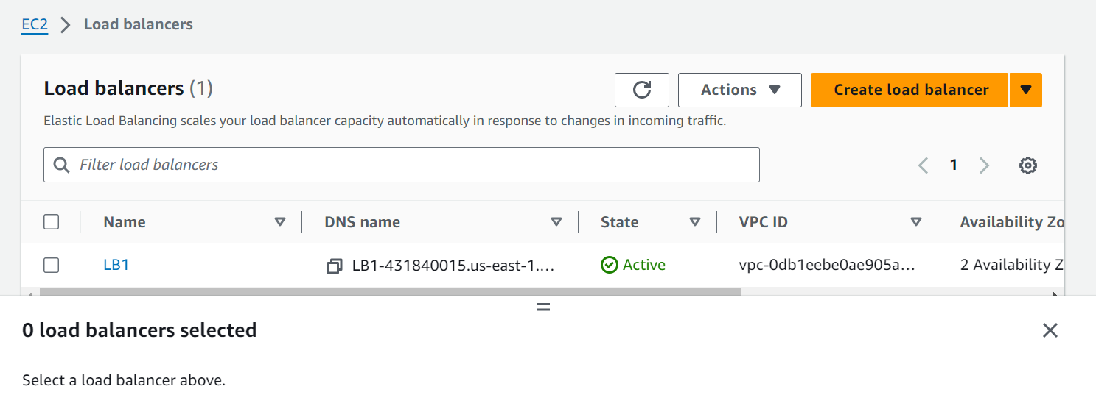

Step 5: Update the Autoscaling Group with the scaling policies and the load balancer configurations.

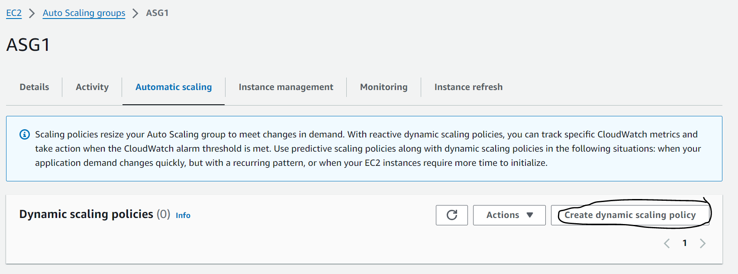

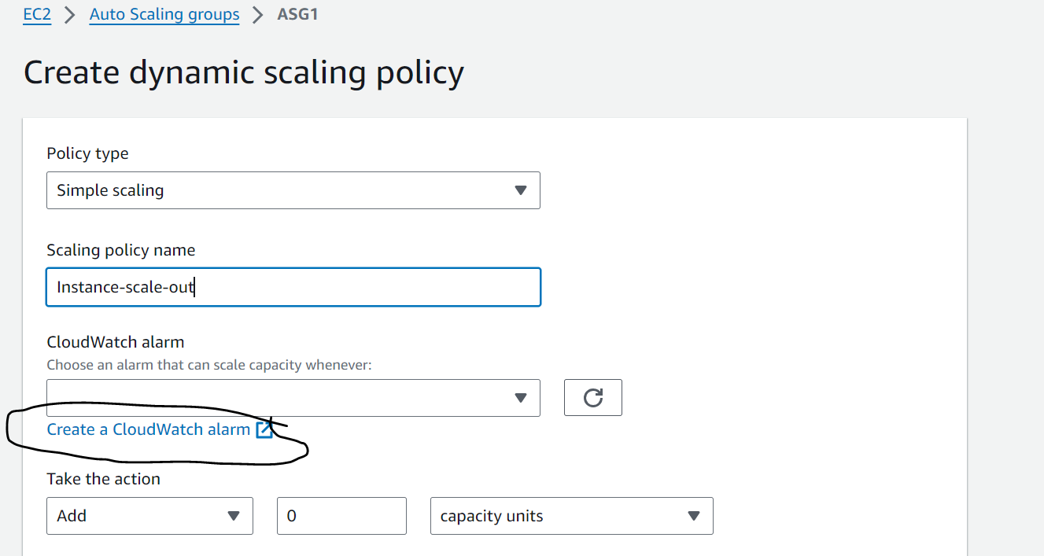

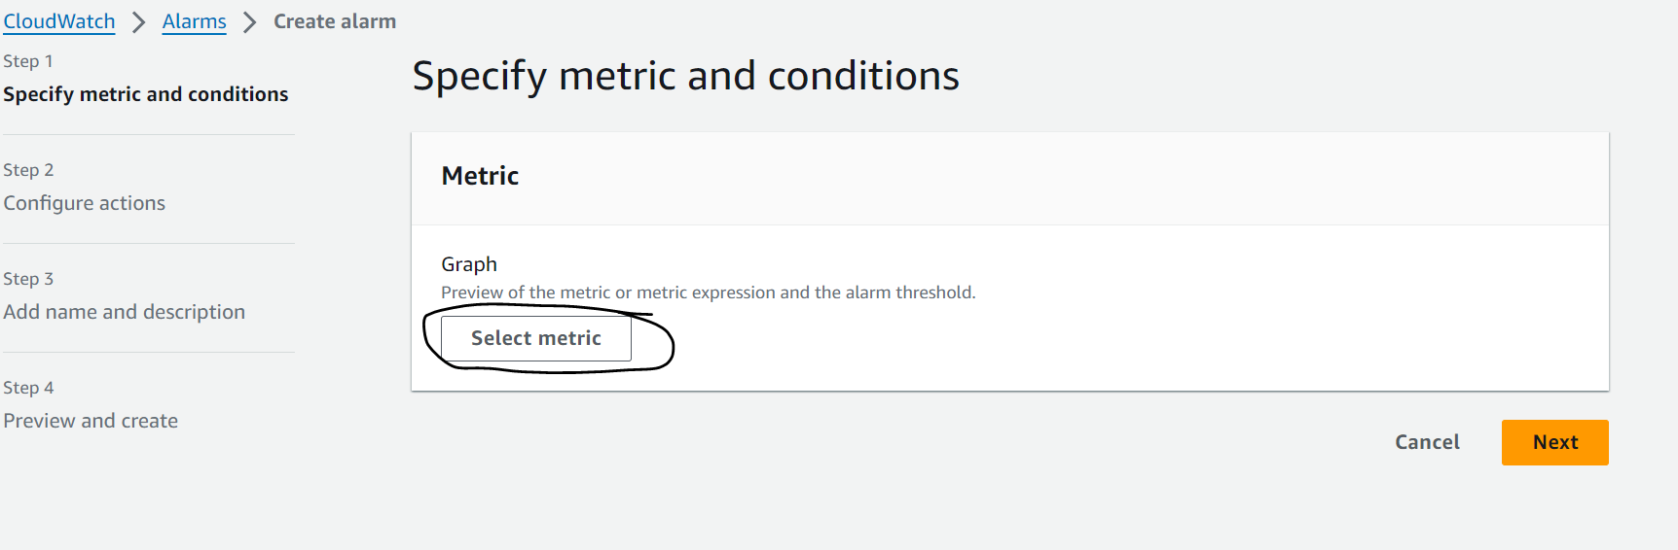

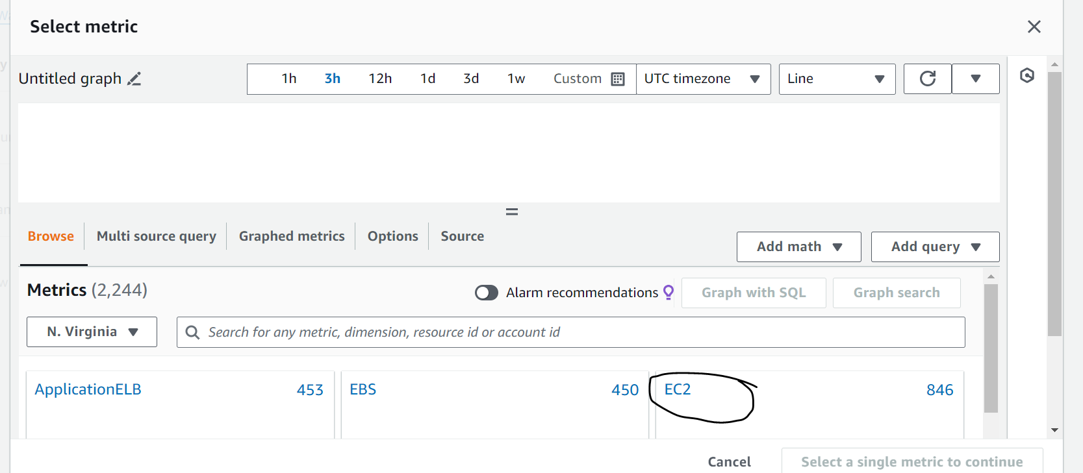

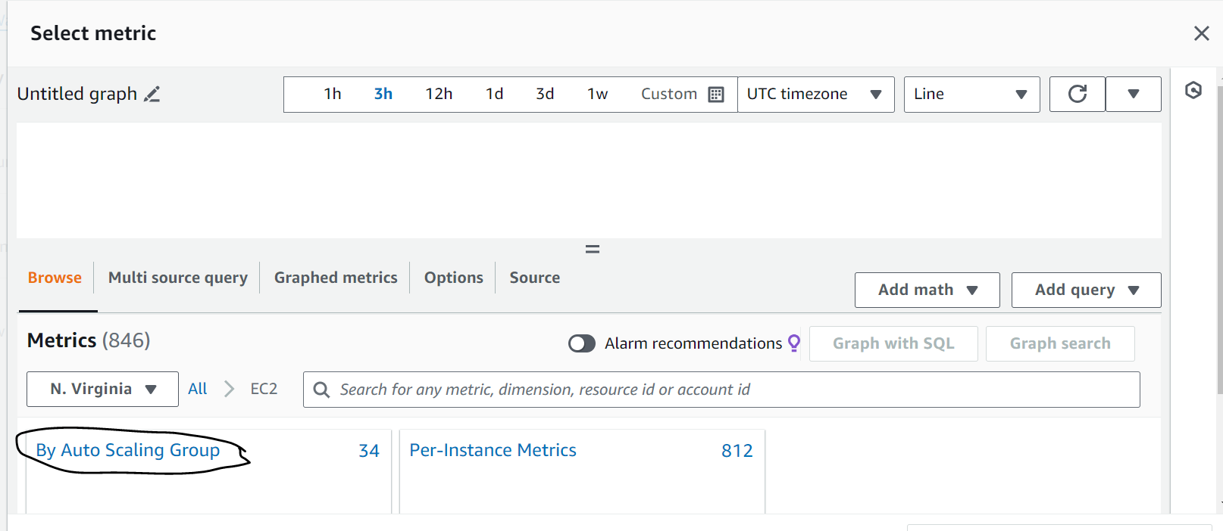

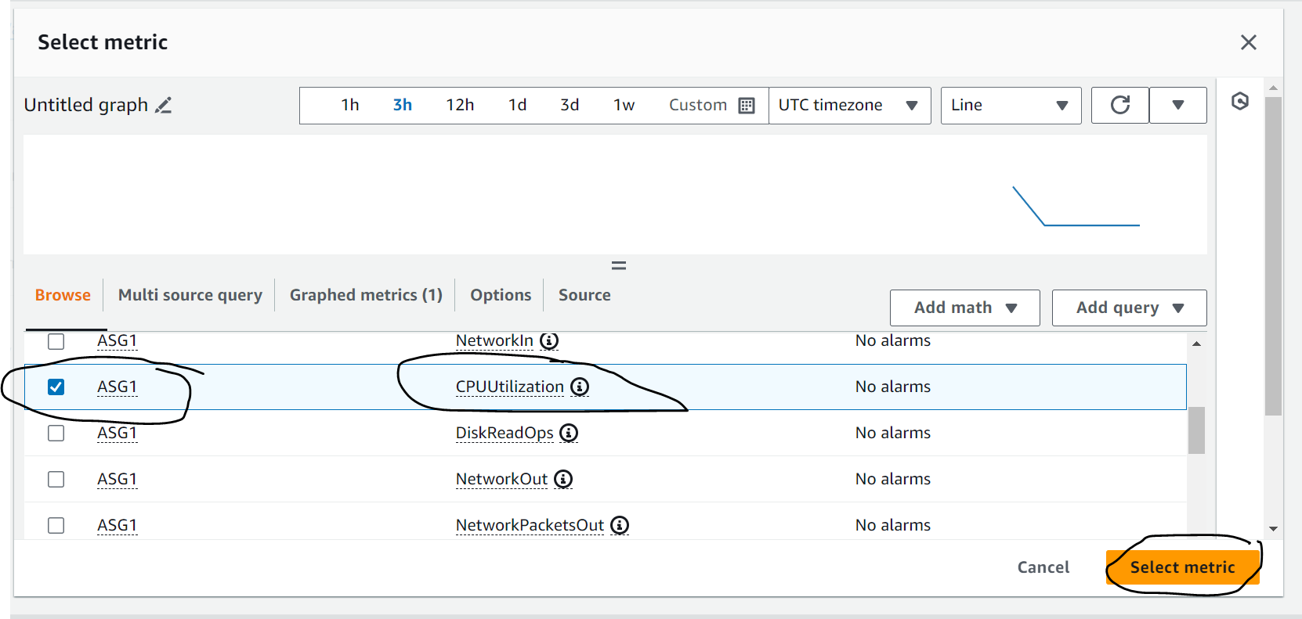

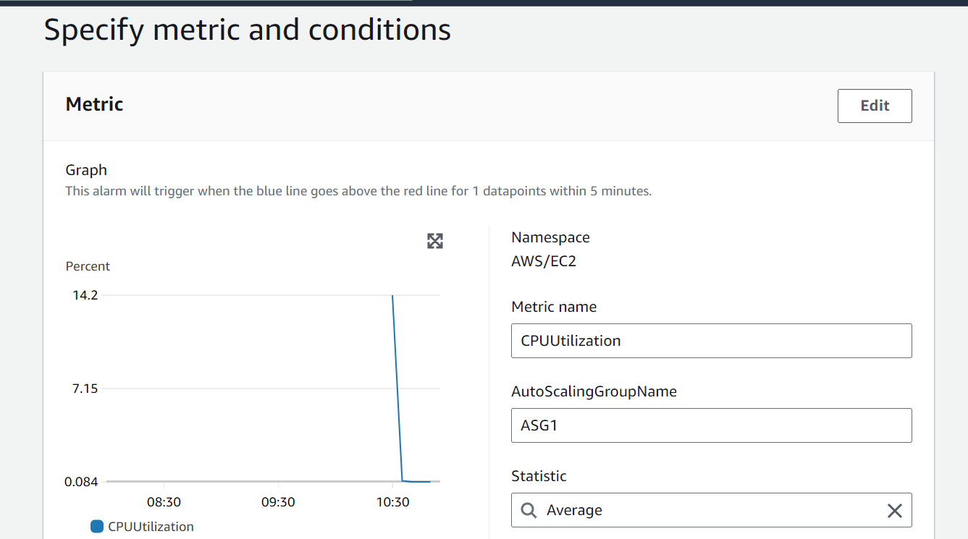

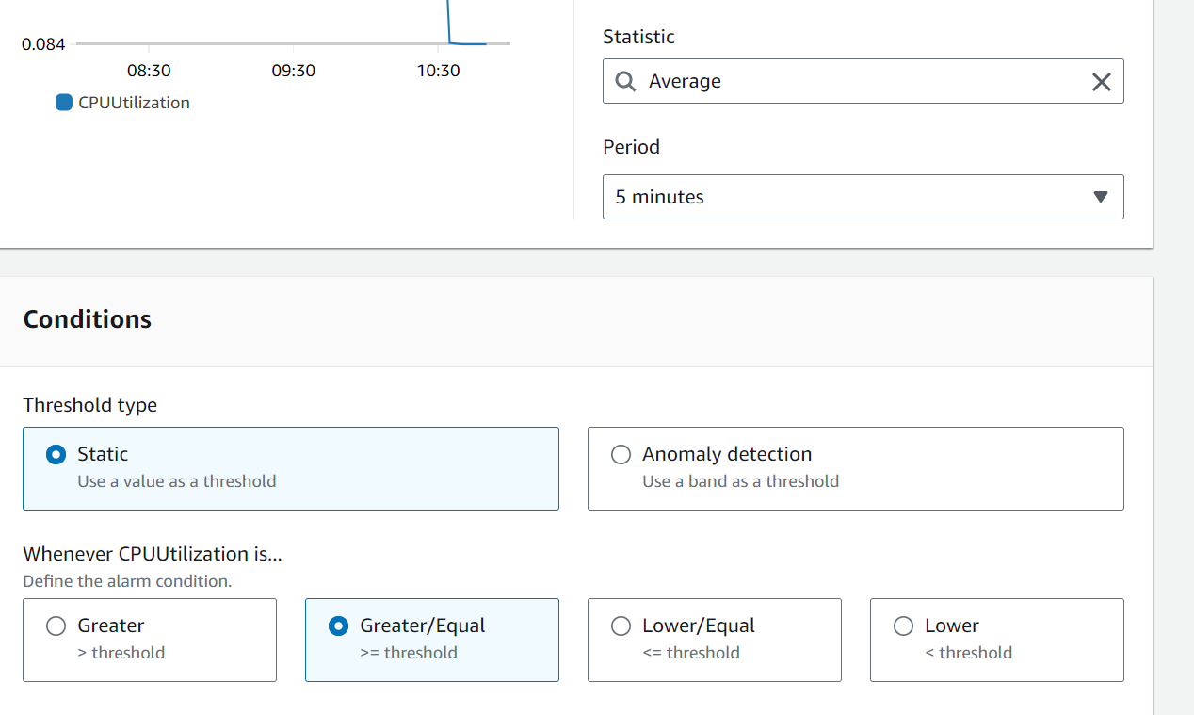

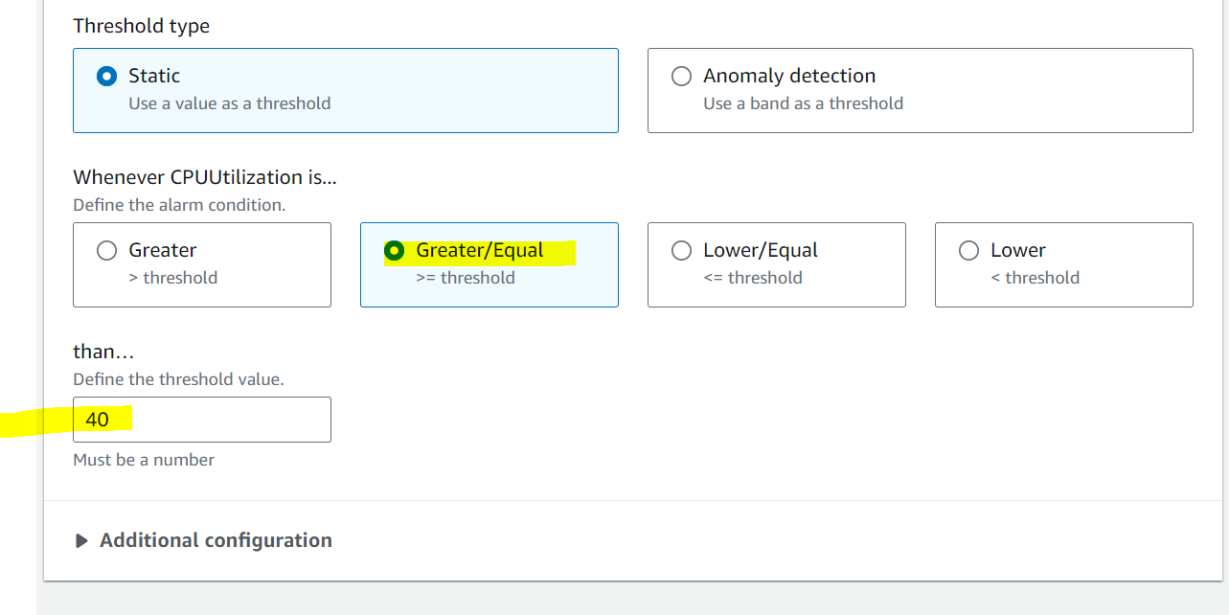

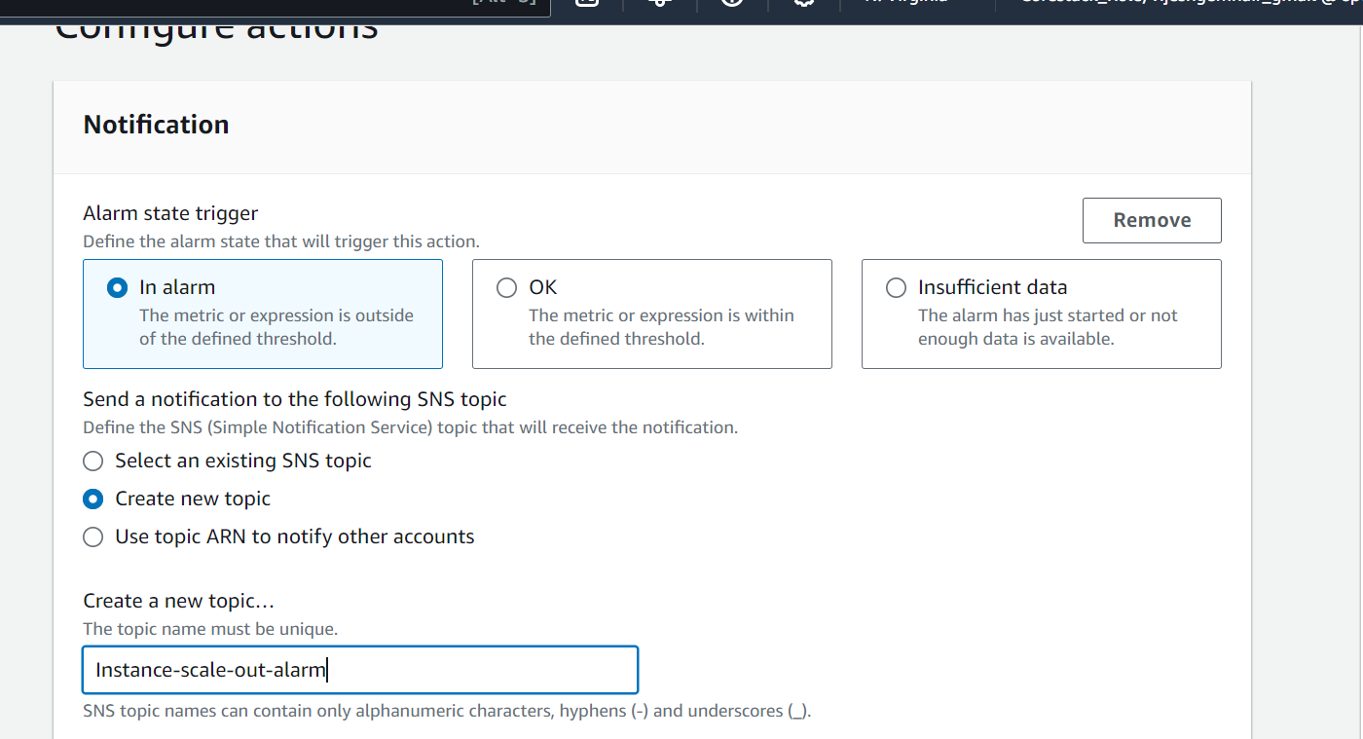

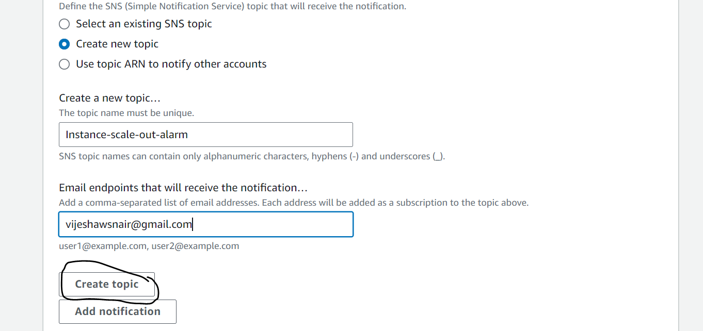

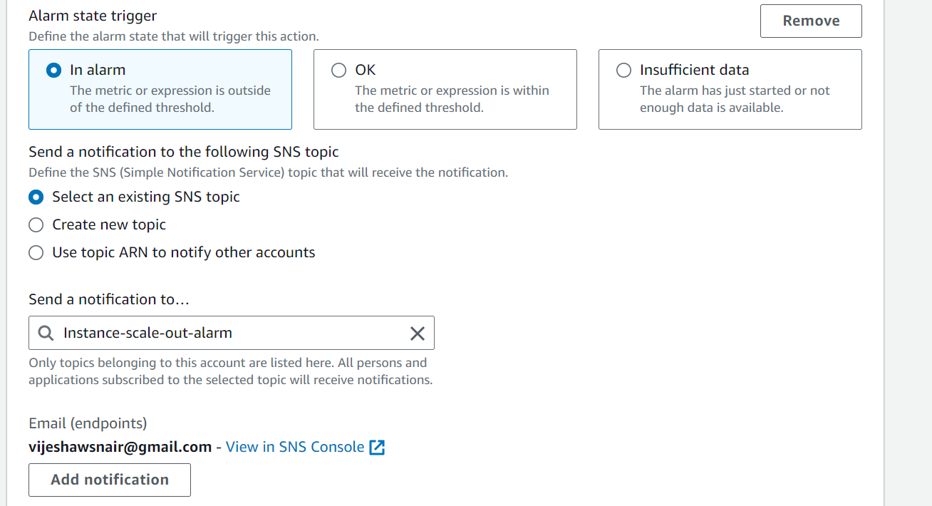

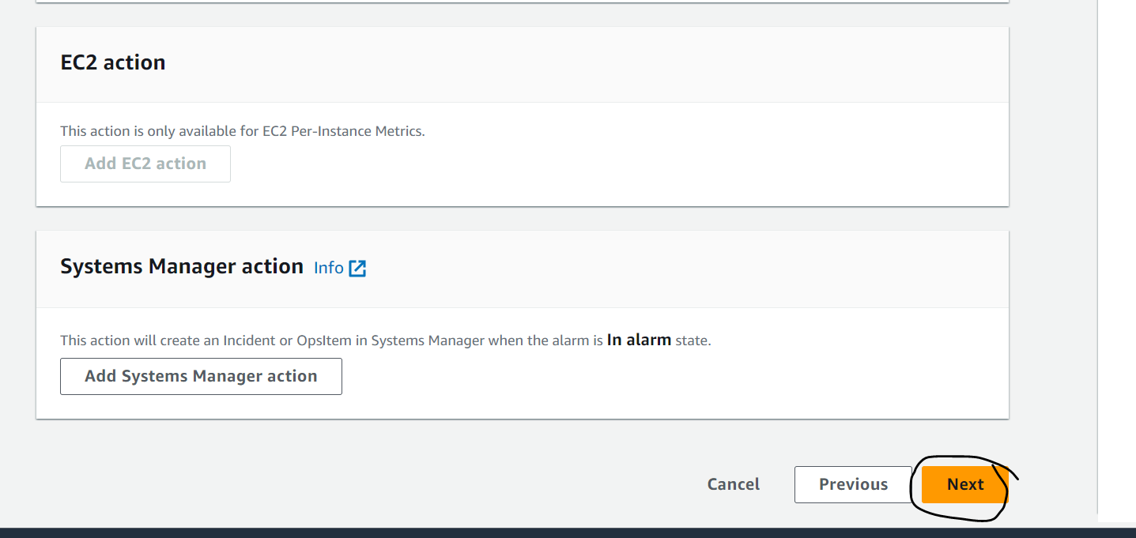

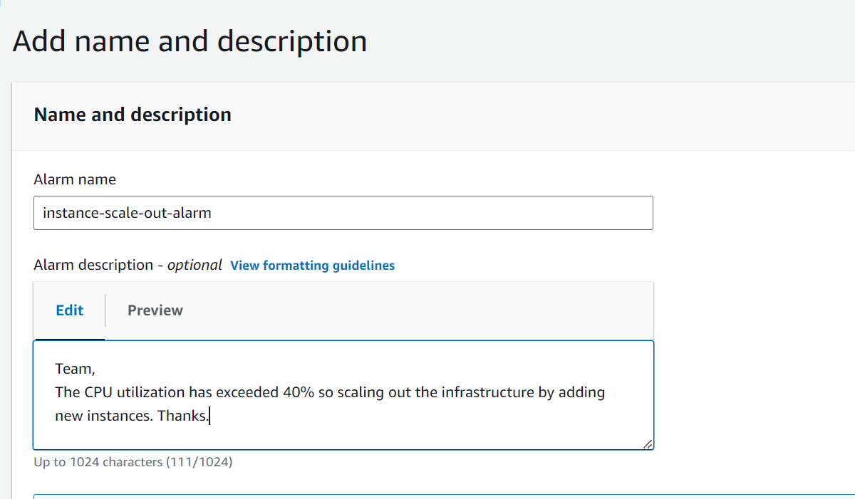

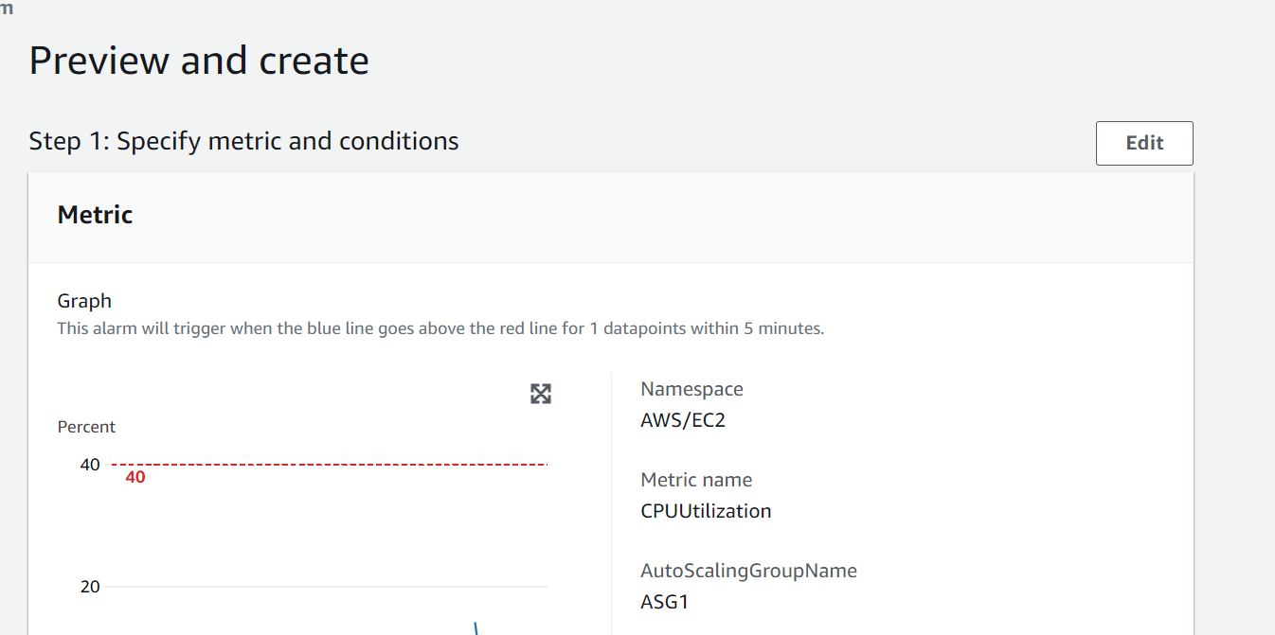

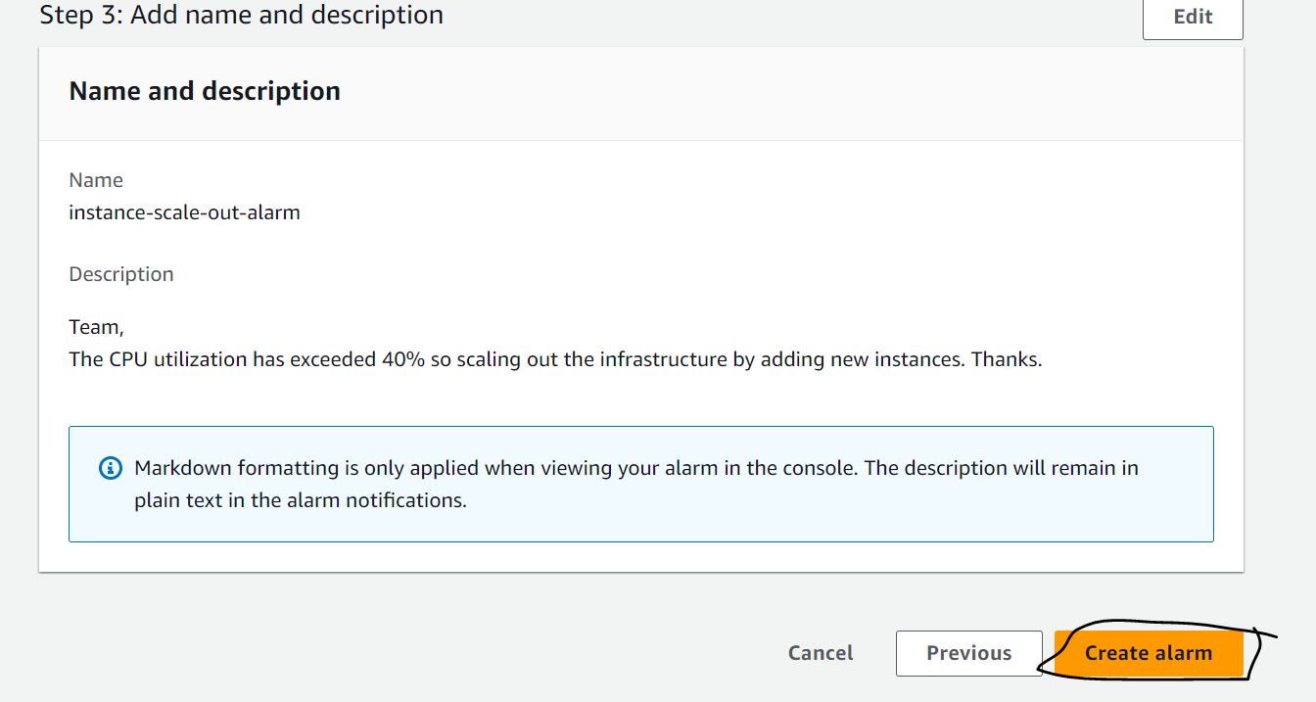

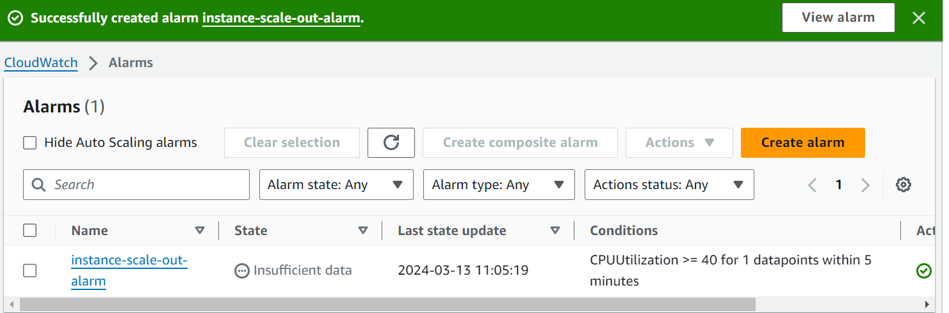

After this got to the mail and confirm the subscription.

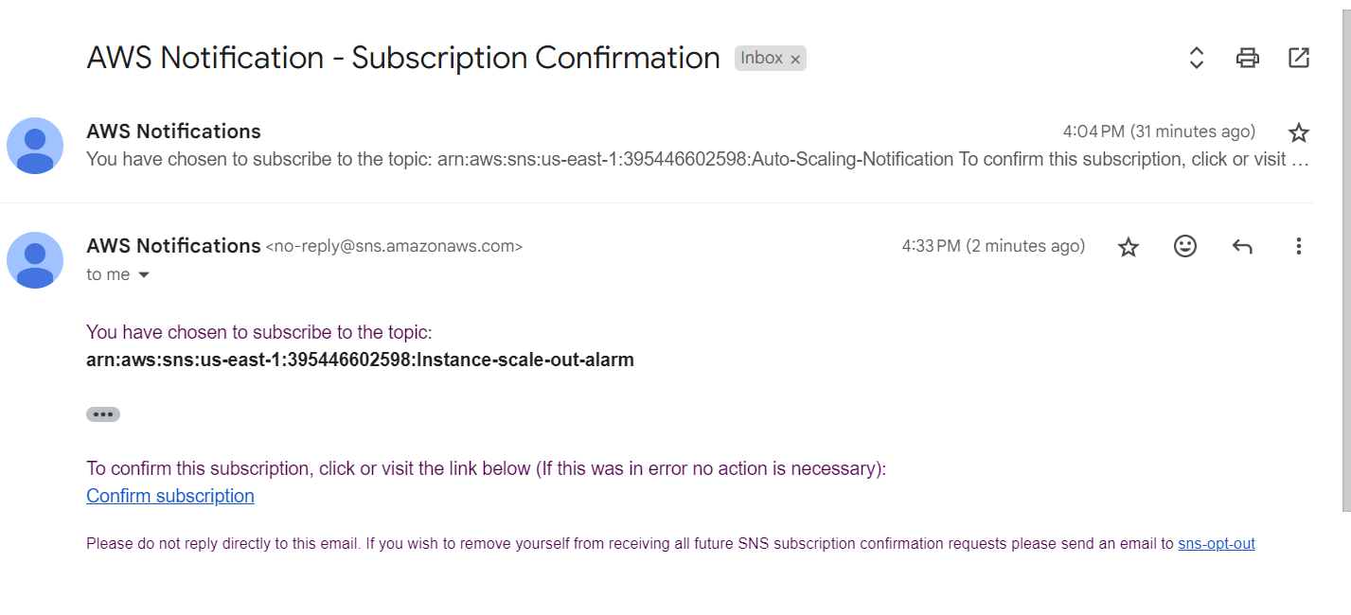

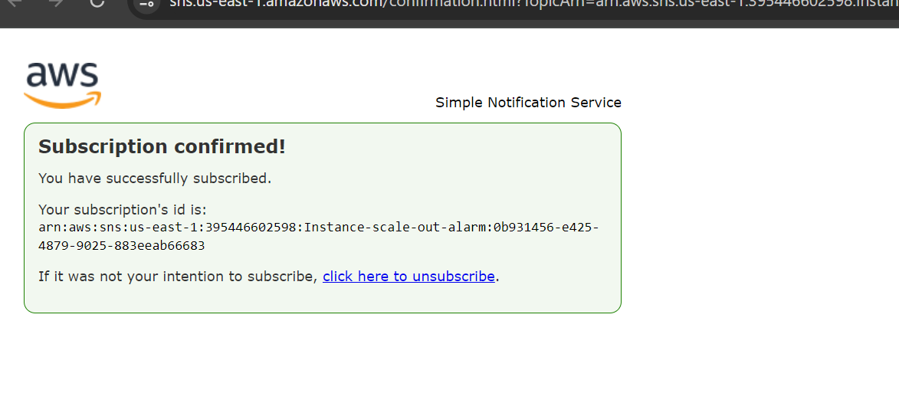

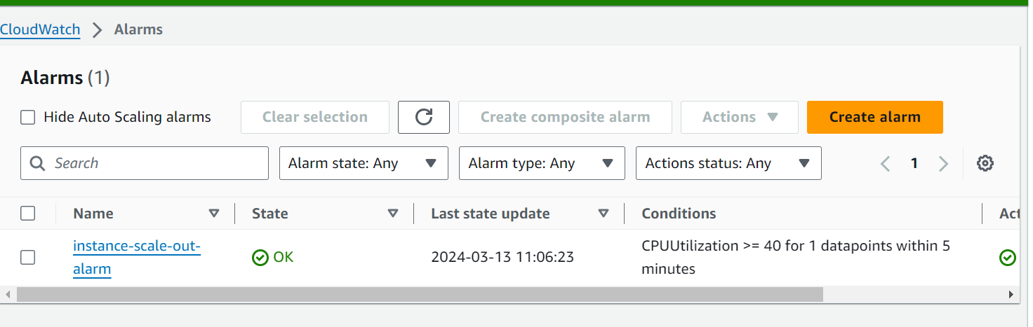

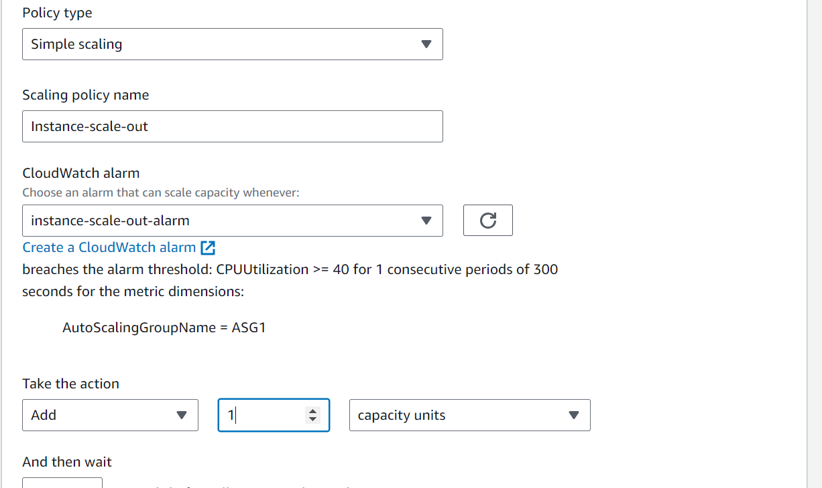

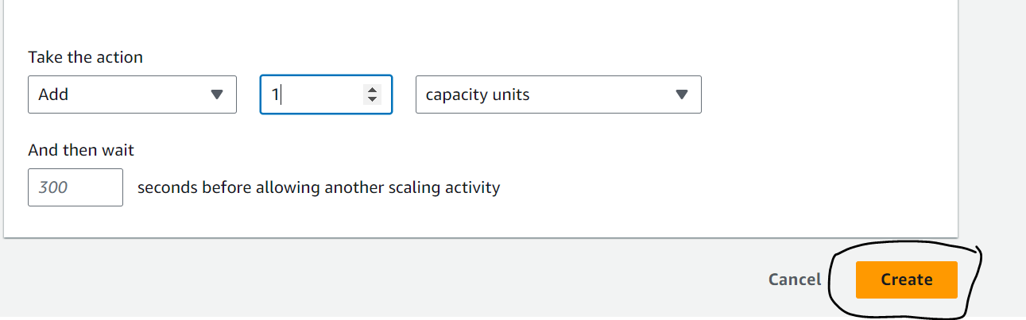

Similar to above we will create another policy for scale in when load is below a threshold:

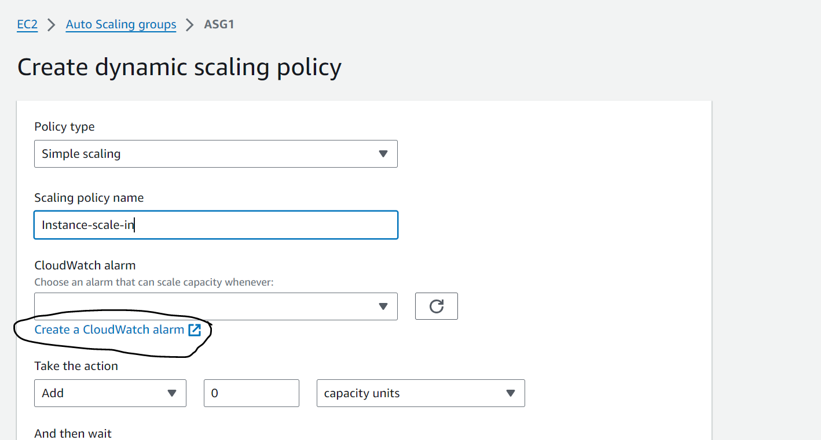

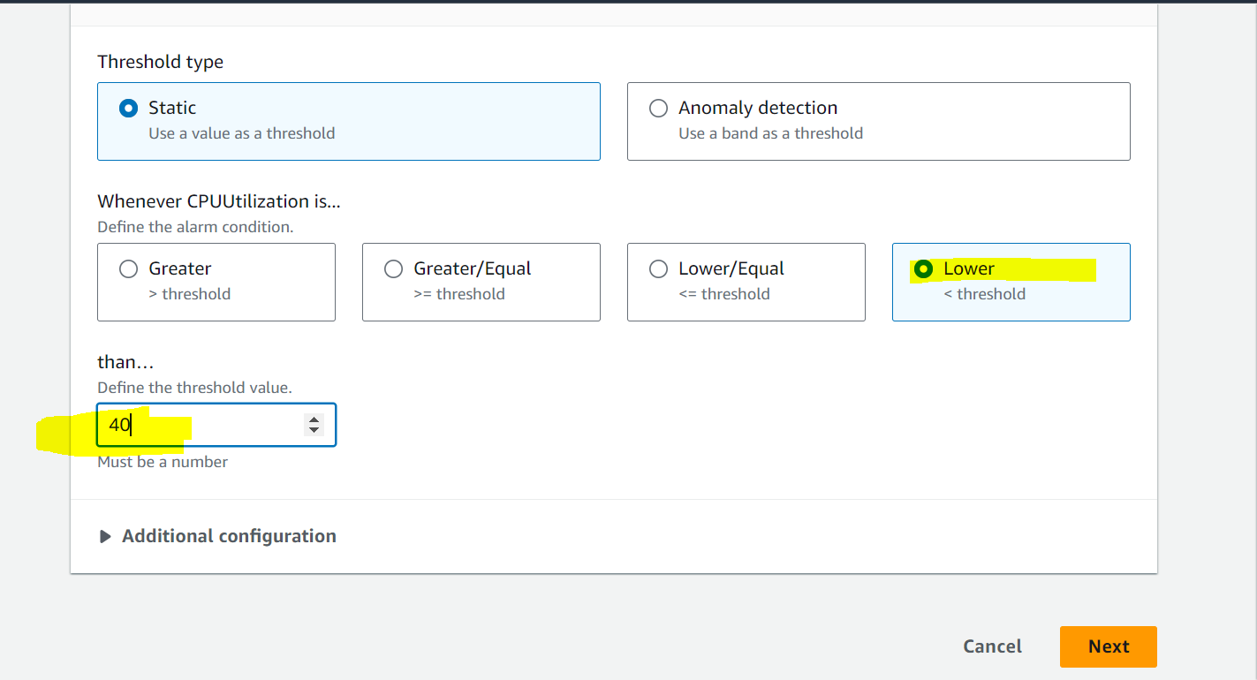

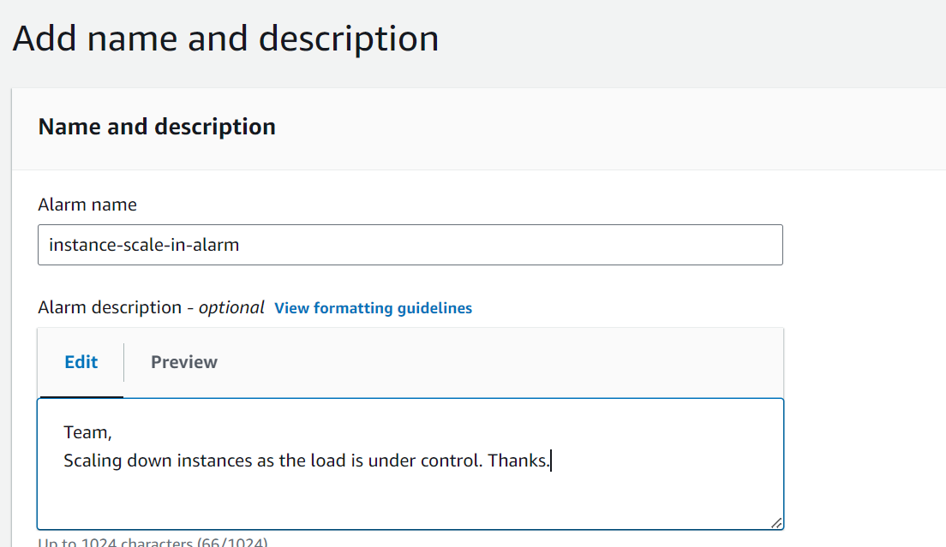

After this got to the mail and confirm the subscription again for scale-in.

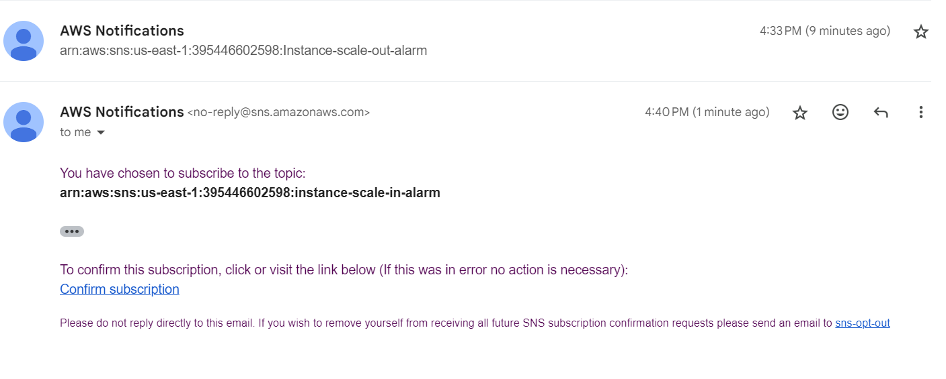

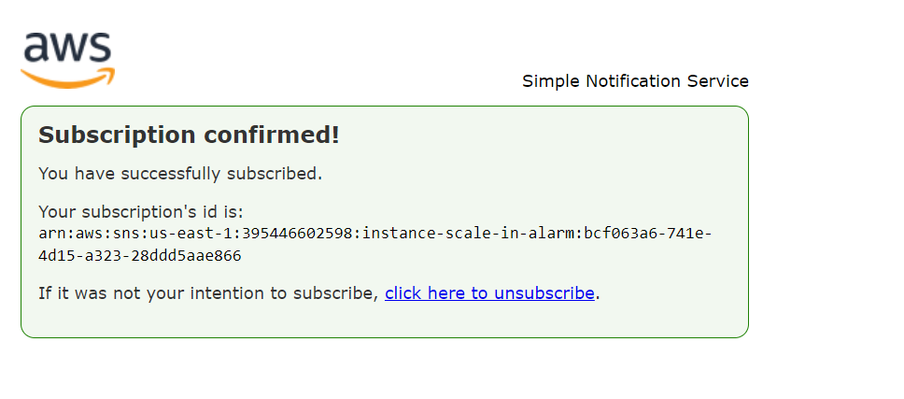

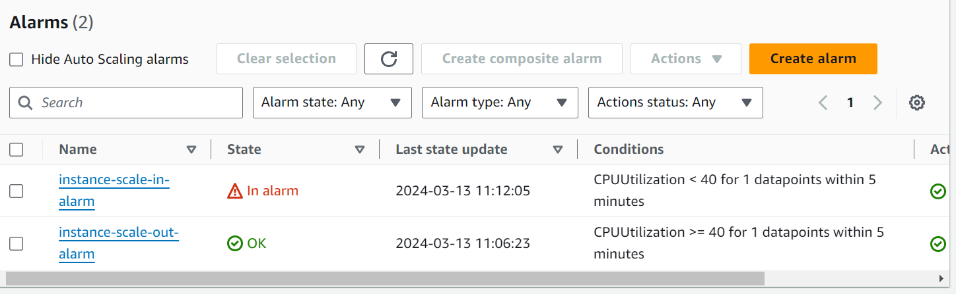

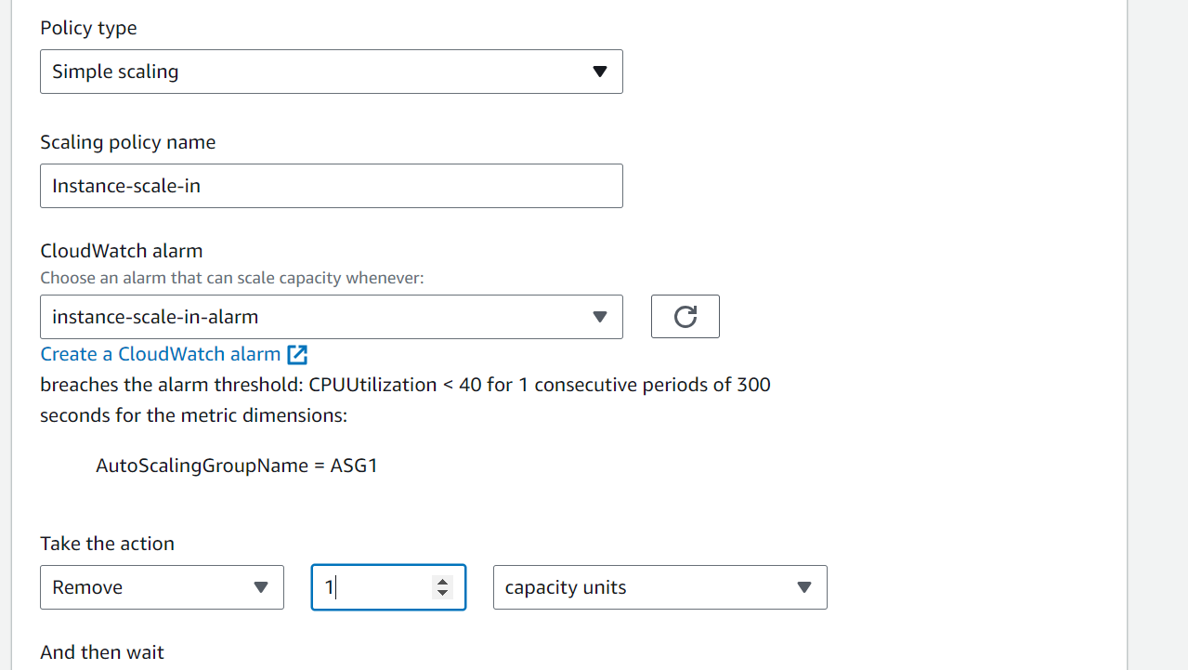

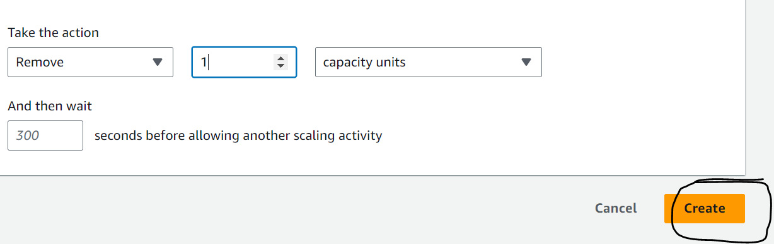

Add load balancer to the autoscaling group now:

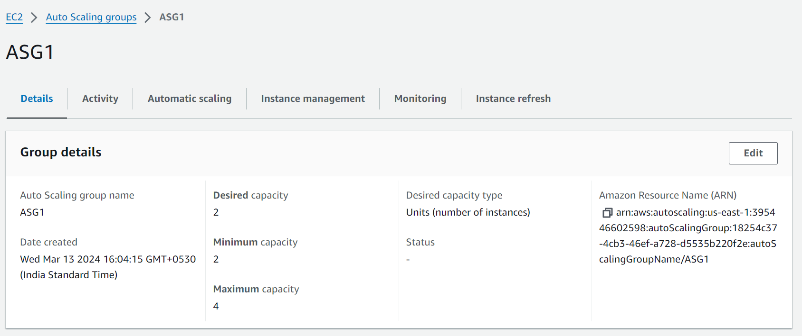

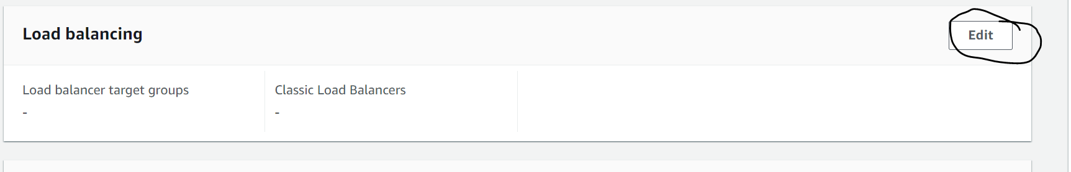

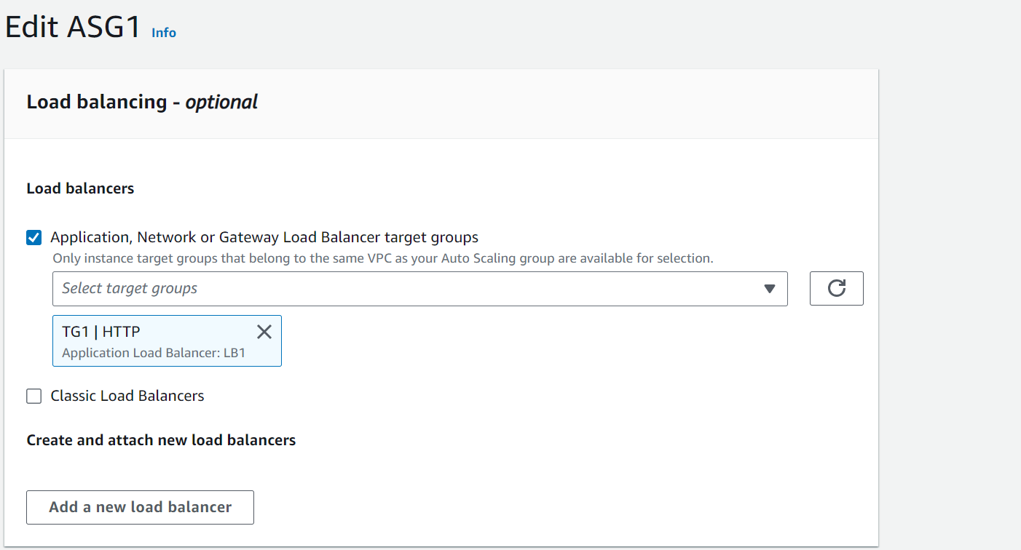

And update.

Step 6: Verify the load balancing using the load balancer DNS name:

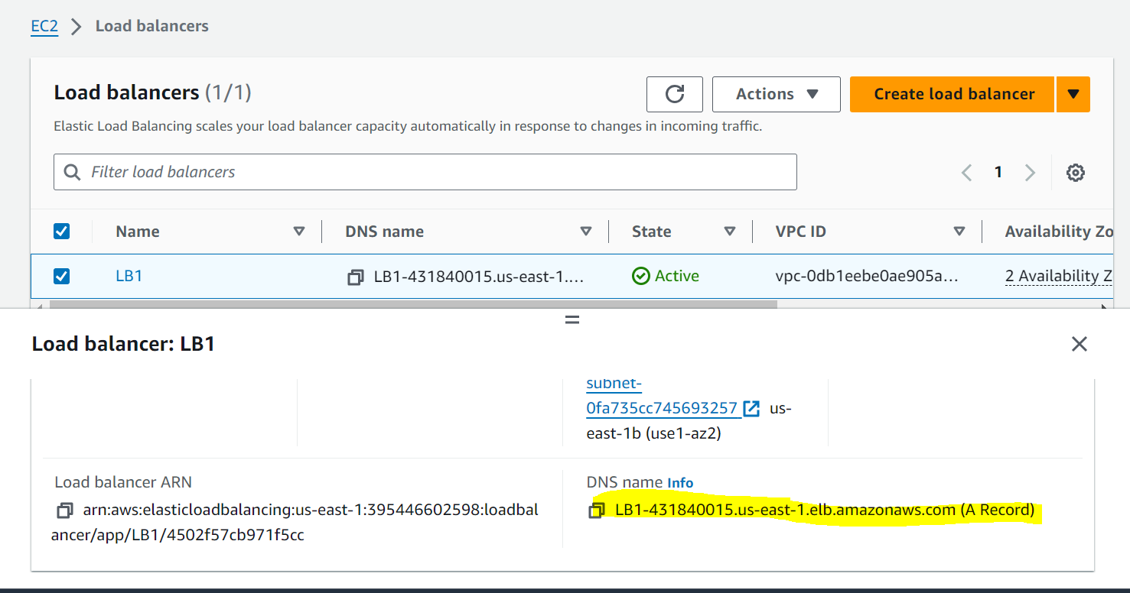





Load balancing is working as it is equally routing the traffic to both instances.

**Autoscaling and Load Balancing Action:**

Step 7: All configurations are done. Now let us launch the my server (public instance) and run a python script to increase load and will check the action.

First you nee to get the keypair of the private instances into your public instance and using that you have to login to the private servers:

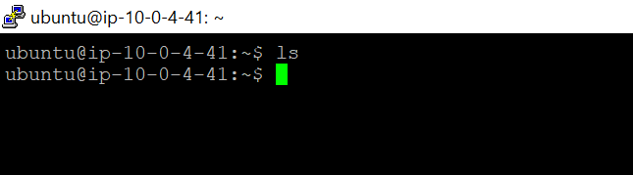

SCP the key using the command prompt from your local to the public instance:

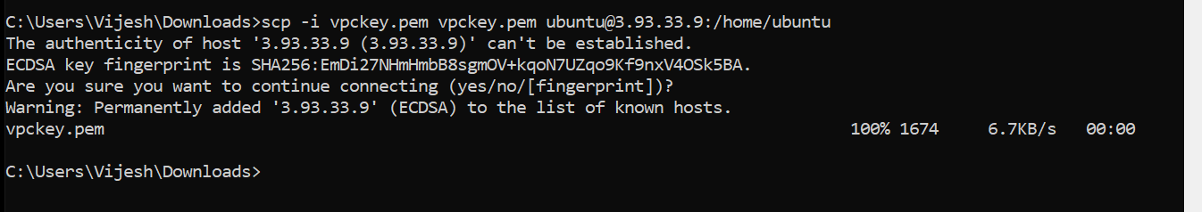

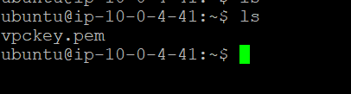

Private Addresses:

Instance 1: 10.0.158.217

Instance 2: 10.0.140.133

Now I will connect to both the private instances from my public server.



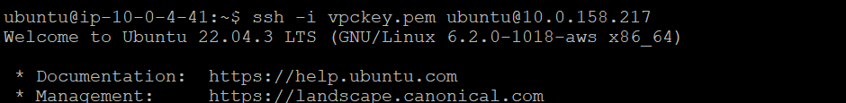

Now create a .py file with the spike script and trigger the python script in both the private instances at the same time.

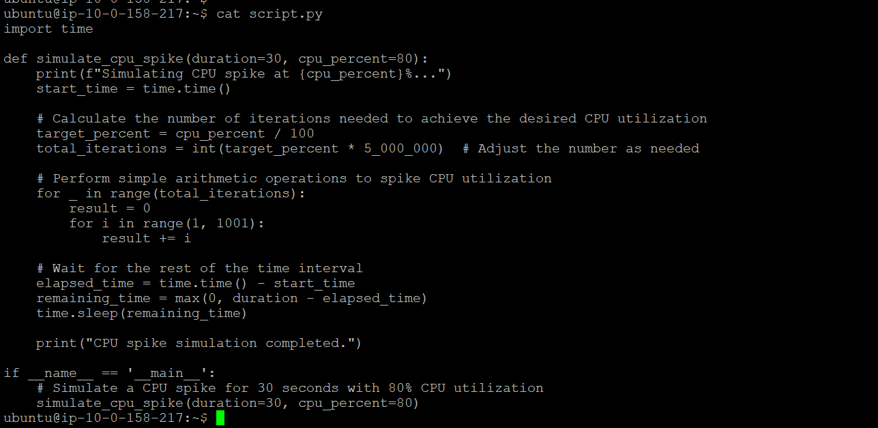

Create the script.py file in both the private instances and trigger the python script.

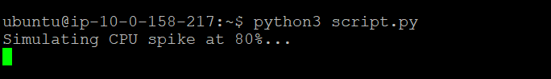

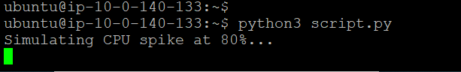

Monitor the cloud CPU utilization of instances:

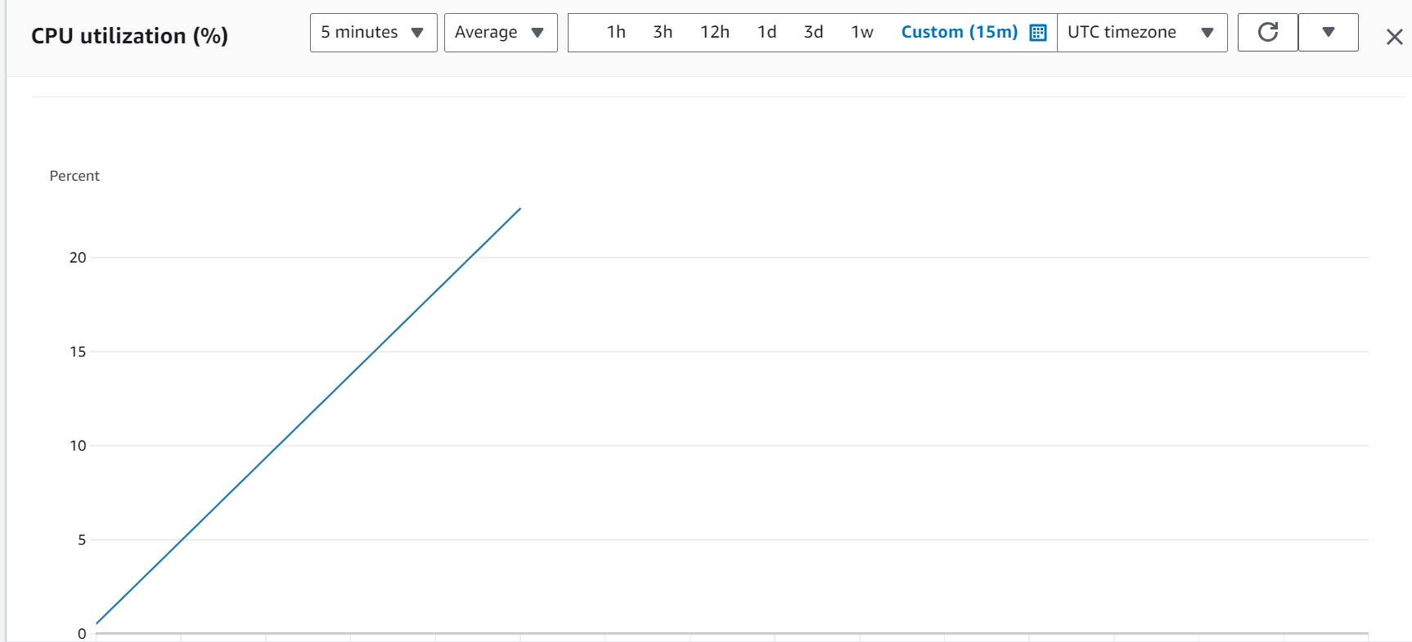

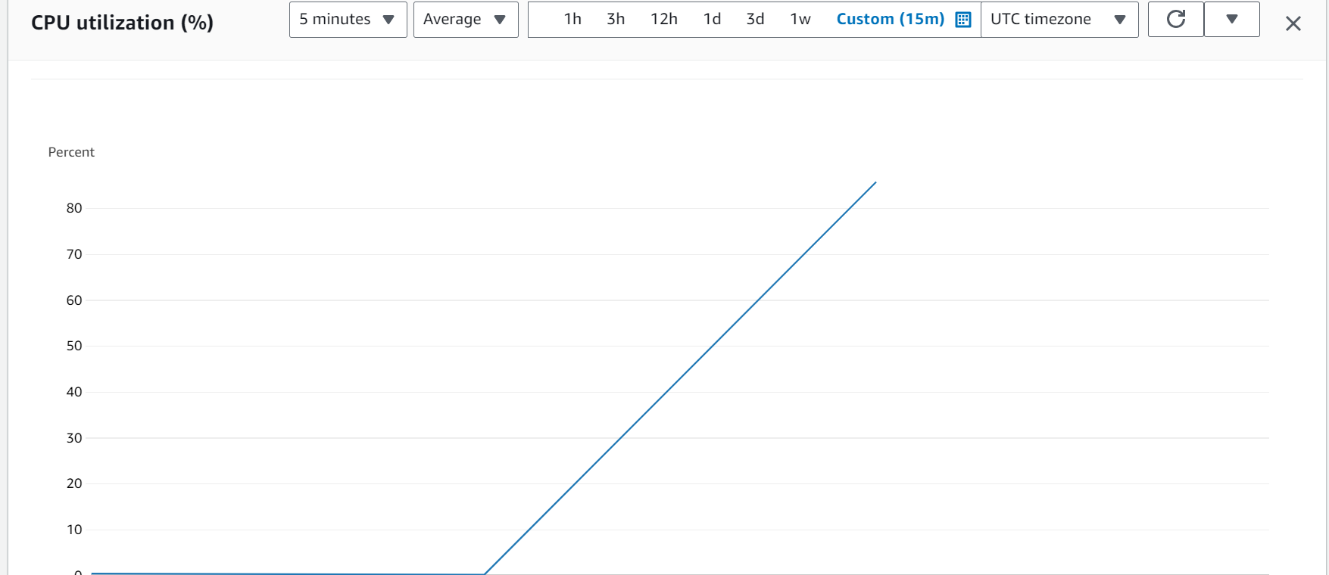

As CPU utilization crosses the threshold one instance is automatically created as below:

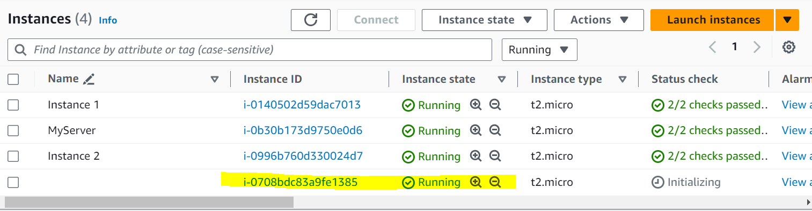



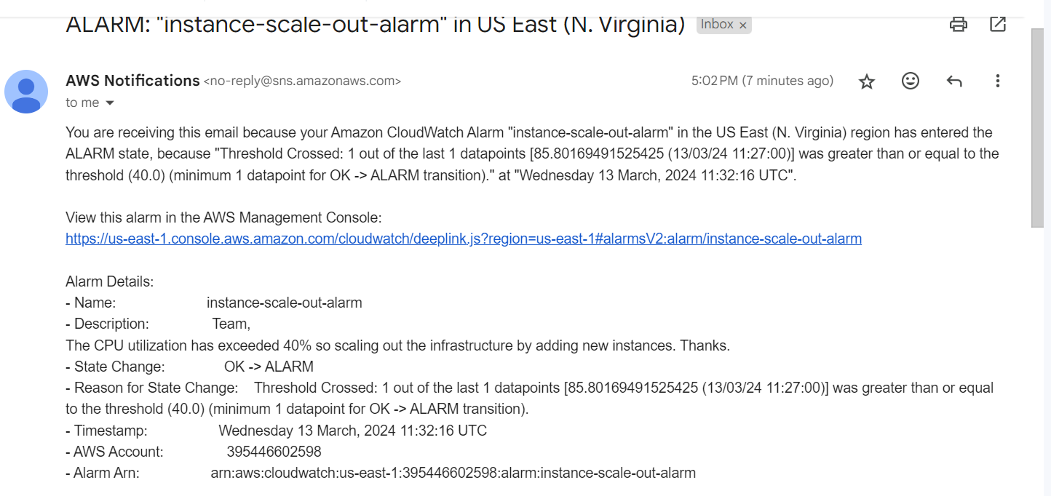

Now we can check the load balancing feature by browsing the DNS :



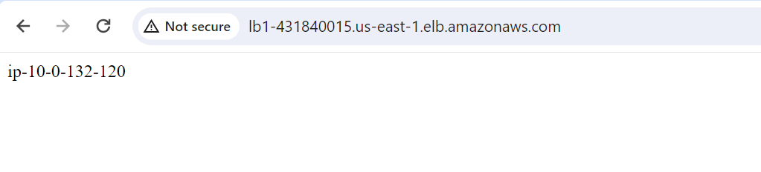



As you see above the load balancer is balancing the load between three instances. Total instances in the target group is now:

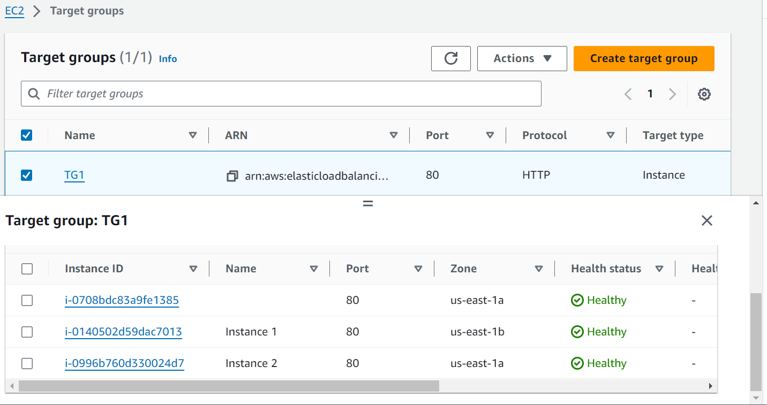

Again create the spike script and check if it is creating one more instance. As you see below one more instance created:

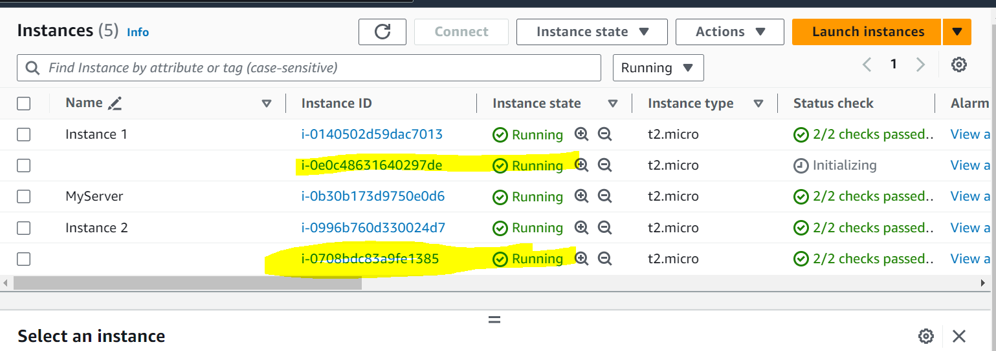

Lets check target group:

Now its 4 instances in target group.

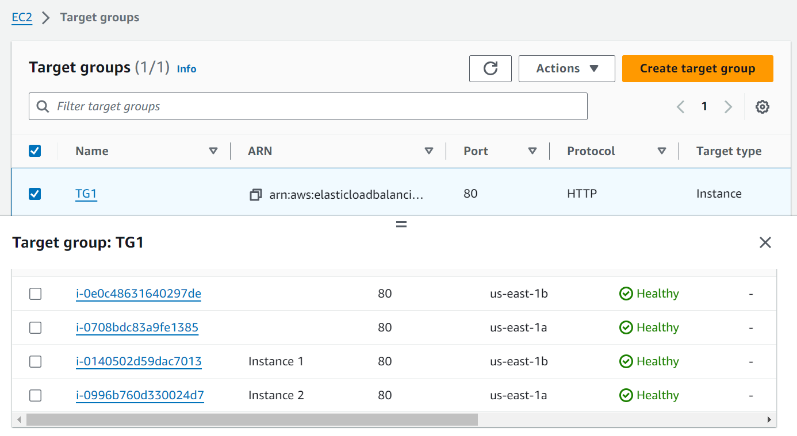

Lets check load balancing:



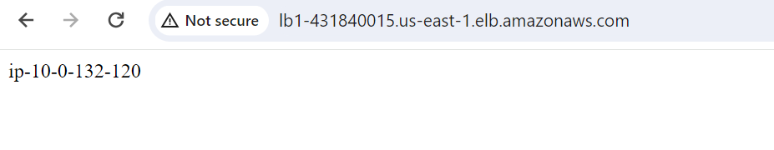

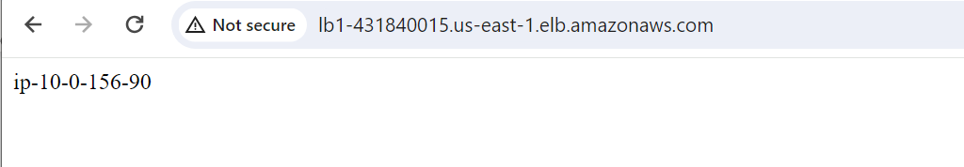

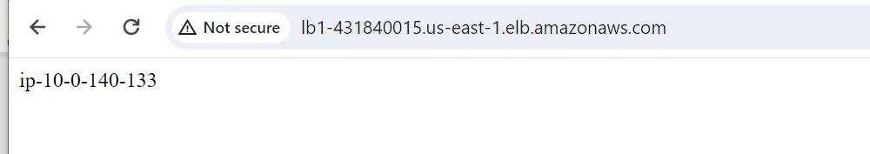

Hence load is balancing across all 4 instances.

Scale-in demonstration:

Lets wait for cpu load to reduce and check the instances.

Once the script stopped running the load minimized and the scale in process started.



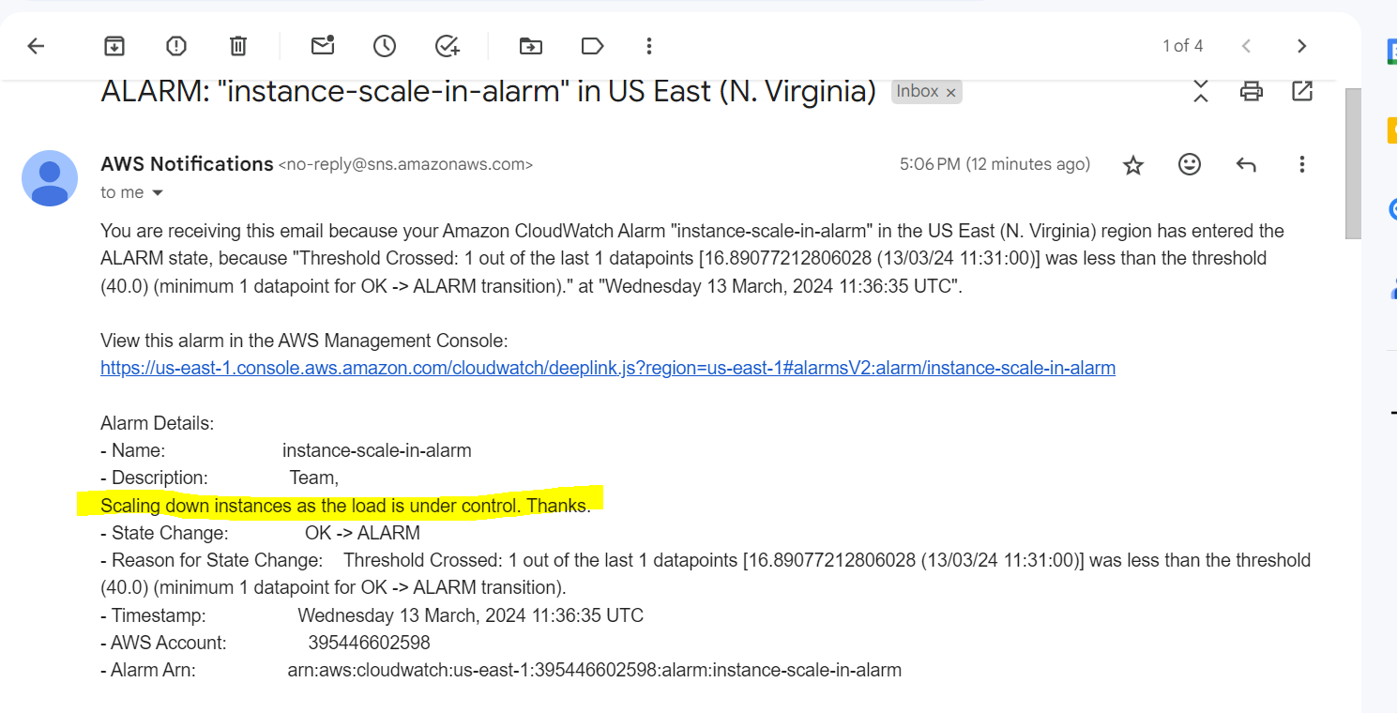

It will take some time to delete the resources first it will drain the instance from the target group and then will terminate the instance.

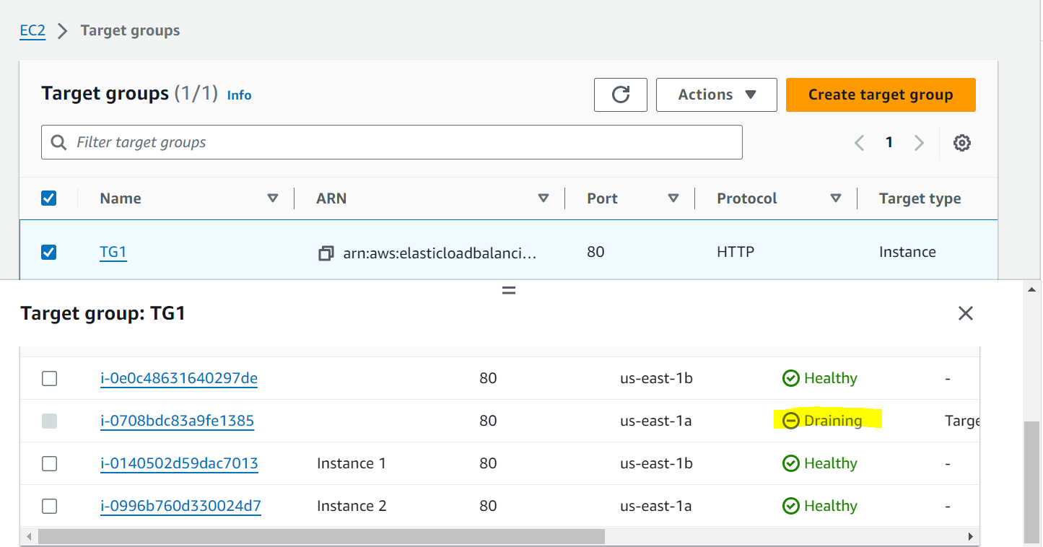

One instance removed:



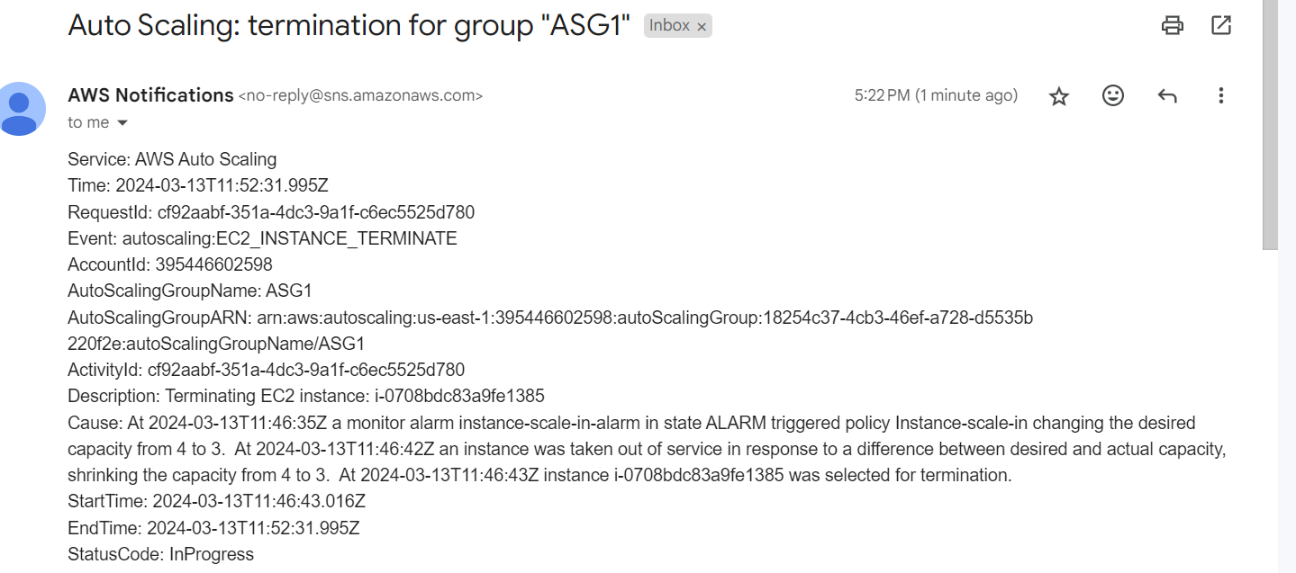

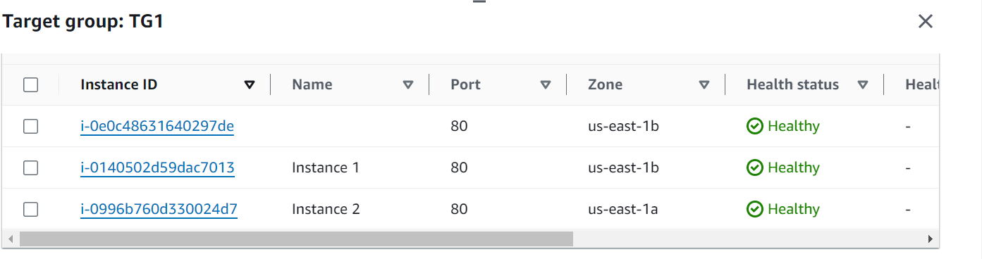

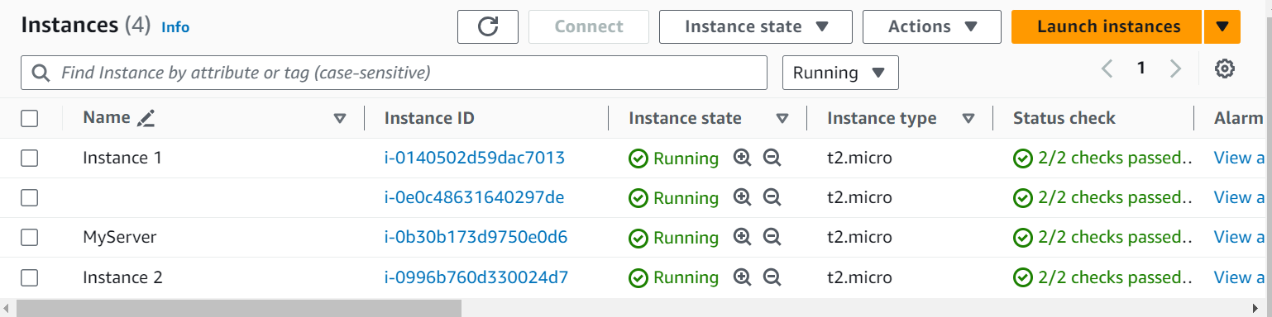

Second instance starting to remove:

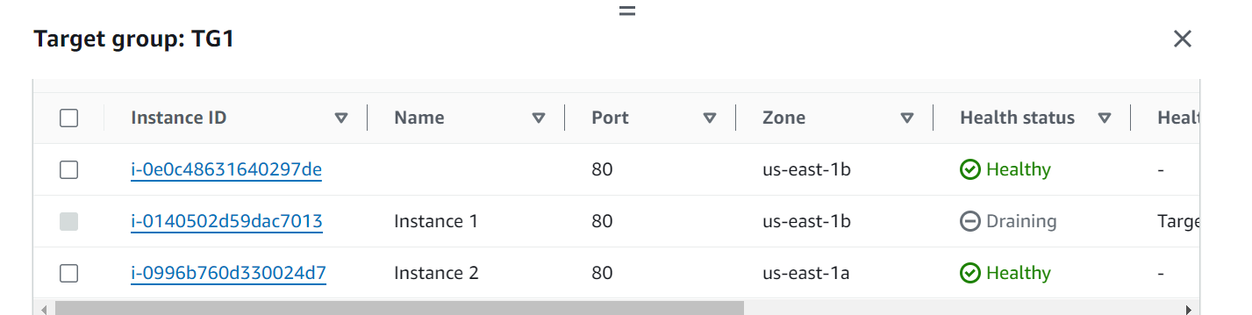

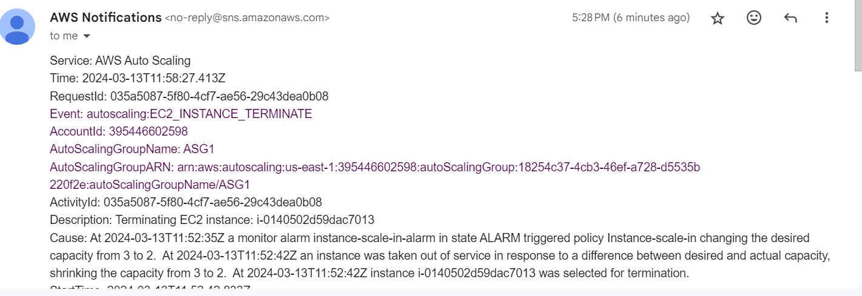

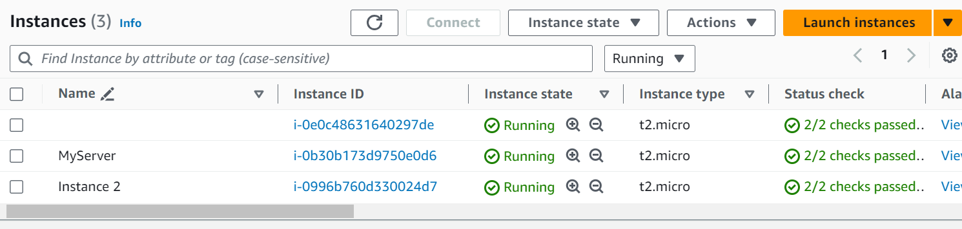

So now we are back to normal state.

Lets finalize load balancing:

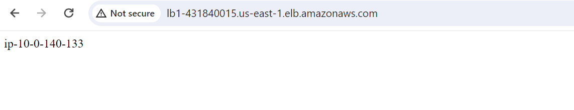

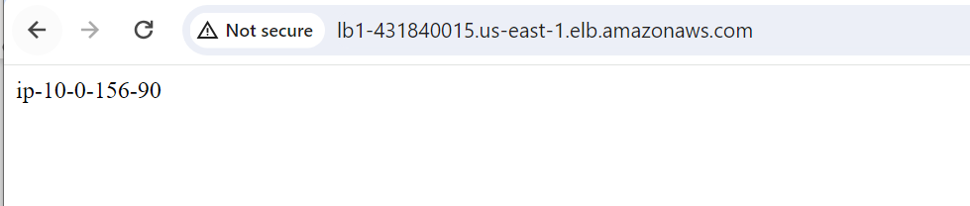

Hence we successfully implemented how to autoscale and load balance based on the loads and everything is working fine.

--------------------------------------Completed--------------------------------------------------------